Regional Identification Prediction from Facial Structure
ABSTRACT:
Deep learning has become one of the most powerful technologies in computer vision, particularly for identifying complex human characteristics from facial images. Regional identification based on facial structures is an emerging area that leverages deep models to analyze patterns and variations across different populations. By training object detection models on diverse datasets, it is possible to extract key visual attributes that help differentiate regional origins. Such systems must balance high performance with fairness, ethical considerations, and careful dataset curation.
This research focuses on building a software-based regional identification system using YOLOv8 architecture. The system is designed to process facial datasets collected from seven different countries: Bhutan, Brazil, Dubai, India, Korea, Nigeria, and South Africa. The model is trained on this dataset and then applied to identify the regional category of unseen facial inputs. Emphasis is placed on accuracy, real-time performance, reproducibility, and a modular design that supports dataset management, model generation, and recognition workflows.
KEYWORDS
Deep learning, YOLOv8, face recognition, regional identification

AIM
To develop a deep-learning-based system capable of predicting the regional origin of facial images using YOLOv8 models trained on multi-country datasets.

OBJECTIVE
The main objective is to implement a software framework that enables training, evaluation, and deployment of a facial structure–based regional identification model, while ensuring efficient recognition, modular operation, and academic value.
PROBLEM STATEMENT
Human facial recognition systems are widely used for identity verification, but regional identification from faces remains underexplored. Traditional approaches lack the robustness and scalability to differentiate faces from diverse global populations. Existing methods often fail to generalize across varied ethnic groups due to dataset imbalance, bias, and limitations in earlier model architectures. The challenge is to design a system that efficiently trains on multi-regional data, accurately predicts unseen cases, and provides an easy-to-use software workflow for academic purposes.

INTRODUCTION
Facial recognition is an active research field that has evolved from handcrafted feature methods to modern deep-learning pipelines. The latest architectures such as YOLOv8 provide high-speed detection capabilities and can be extended for specialized classification tasks. Their modularity and efficiency make them suitable for tasks such as regional identification, where rapid image processing and robust feature extraction are critical.
Regional prediction from facial features is challenging due to intra-class variations such as age, gender, expression, and external conditions like lighting and pose. Unlike standard identity recognition, regional classification focuses on structural and cultural facial variations across populations, requiring carefully curated and balanced datasets. The adoption of datasets spanning multiple countries ensures exposure to diverse facial characteristics, enabling models to learn robust discriminative features.
Despite the potential of deep models, the field faces ethical and technical hurdles. Dataset biases can lead to skewed performance across groups, raising fairness concerns. Therefore, dataset design and reporting of per-region performance metrics must be a central part of system evaluation. Documenting these issues is essential for any academic project dealing with demographic attributes.
YOLOv8’s strength lies in its real-time detection ability and the flexibility to incorporate classification heads. The detection stage isolates facial regions, ensuring that the classifier focuses on the most relevant parts of the image. This pipeline reduces noise from the background and improves model accuracy, making it suitable for regional identification tasks.
Another important aspect is reproducibility. The system must log dataset versions, training configurations, and model metrics. Academic projects require reproducible experiments, allowing others to replicate results under similar conditions. Implementing training pipelines with controlled seeds, standardized logging, and versioned datasets ensures scientific credibility.
Finally, while the project demonstrates technical feasibility, it emphasizes that regional prediction systems should be used only for controlled academic research. In real-world applications, caution must be exercised to prevent misuse. This ensures the project contributes knowledge to computer vision while acknowledging its limitations.

SYSTEM ANALYSIS
EXISTING SYSTEM
Current facial recognition systems predominantly focus on identity verification and authentication, not regional classification. Some frameworks can detect demographic attributes such as age or gender, but they do not address fine-grained regional differences. Older systems rely on shallow machine learning or handcrafted features, which lack robustness under varied conditions. Newer systems may use CNN backbones but rarely offer modular tools for dataset upload, model generation, and structured recognition workflows.

DISADVANTAGES:
- Bias and unfair performance due to unbalanced or limited datasets
- Lack of modularity in existing tools for academic use
- Reduced performance under noisy or uncontrolled input conditions

PROPOSED SYSTEM
The proposed system uses YOLOv8 as the backbone for face detection and classification. It integrates a structured pipeline that allows datasets from seven countries to be uploaded, validated, and used for training a classification-capable YOLOv8 model. Once trained, the model can recognize new facial images and predict their regional class. The system emphasizes modular separation of dataset management, model training, and recognition functions. It also incorporates reproducibility, ensuring that training logs, model versions, and evaluation metrics are consistently recorded for academic validation.
ADVANTAGES
- Fast and accurate recognition using YOLOv8
- Dataset-driven modular design with support for multiple countries
- Academic reproducibility with logs and model versioning
- Clear separation of dataset management and recognition processes

SYSTEM REQUIREMENTS:
HARDWARE REQUIREMENTS:

- Processor : Intel iConre
- SSD : 512 GB.
- Ram : 8 GB

SOFTWARE REQUIREMENTS:

- Operating system : Windows 11.
- Coding Language : python
- Tool : pycharm
- Database : mysql
- framework : Django
- Technologies : pdbc, Deep Learning

FUNCTIONAL REQUIREMENTS

Admin Functions
- Login – The admin must authenticate securely before accessing the system.
- Upload Dataset – The admin can upload facial datasets belonging to the 7 countries {Bhutan, Brazil, Dubai, India, Korea, Nigeria, South_Africa}.
- Generate Model – The admin can initiate training of a YOLOv8 model using the uploaded datasets.
- Store Model – The trained model should be saved
- Logout – The admin can log out after completing tasks.
User Functions
- Registration – Users can register with unique credentials.
- Login – Users must log in to access recognition services.
- Upload Image – Users can upload trained person images for recognition.
- Face Recognition – The system loads the latest YOLOv8 model, runs detection & classification, and predicts the regional category.
- View Results – The recognition result (predicted country with confidence score) is displayed to the user.
- Logout – Users can log out after recognition.
NON-FUNCTIONAL REQUIREMENTS
- Performance
  - Training jobs must complete within reasonable timeframes depending on dataset size.
  - Inference (recognition) should respond in < 3 seconds for a single image.
- Scalability
  - The system should support uploading larger datasets and retraining without requiring major architectural changes.
  - Capable of handling concurrent user recognition requests.
- Security
  - Encrypt user credentials and sensitive data.
  - Restrict admin-only functions (dataset upload, model training).
- Reliability & Availability
  - Ensure recognition service is available with minimal downtime.
  - Provide backup mechanisms for datasets and models.
- Usability
  - Simple and intuitive interface for both admin (dataset/model) and user (image upload/recognition).
  - Provide meaningful error messages (e.g., invalid file format, failed recognition).
- Maintainability
  - Modular design separating admin functions, user functions, and core recognition logic.
  - Easy to update or replace the YOLOv8 model with newer versions.
- Reproducibility
  - Store model metadata (training dataset, hyperparameters, accuracy) to reproduce experiments.
- Privacy & Ethics
  - Ensure uploaded images are stored securely and deleted on user request.
  - Explicitly restrict system use to academic and research purposes only.

SYSTEM ARCHITECTURE
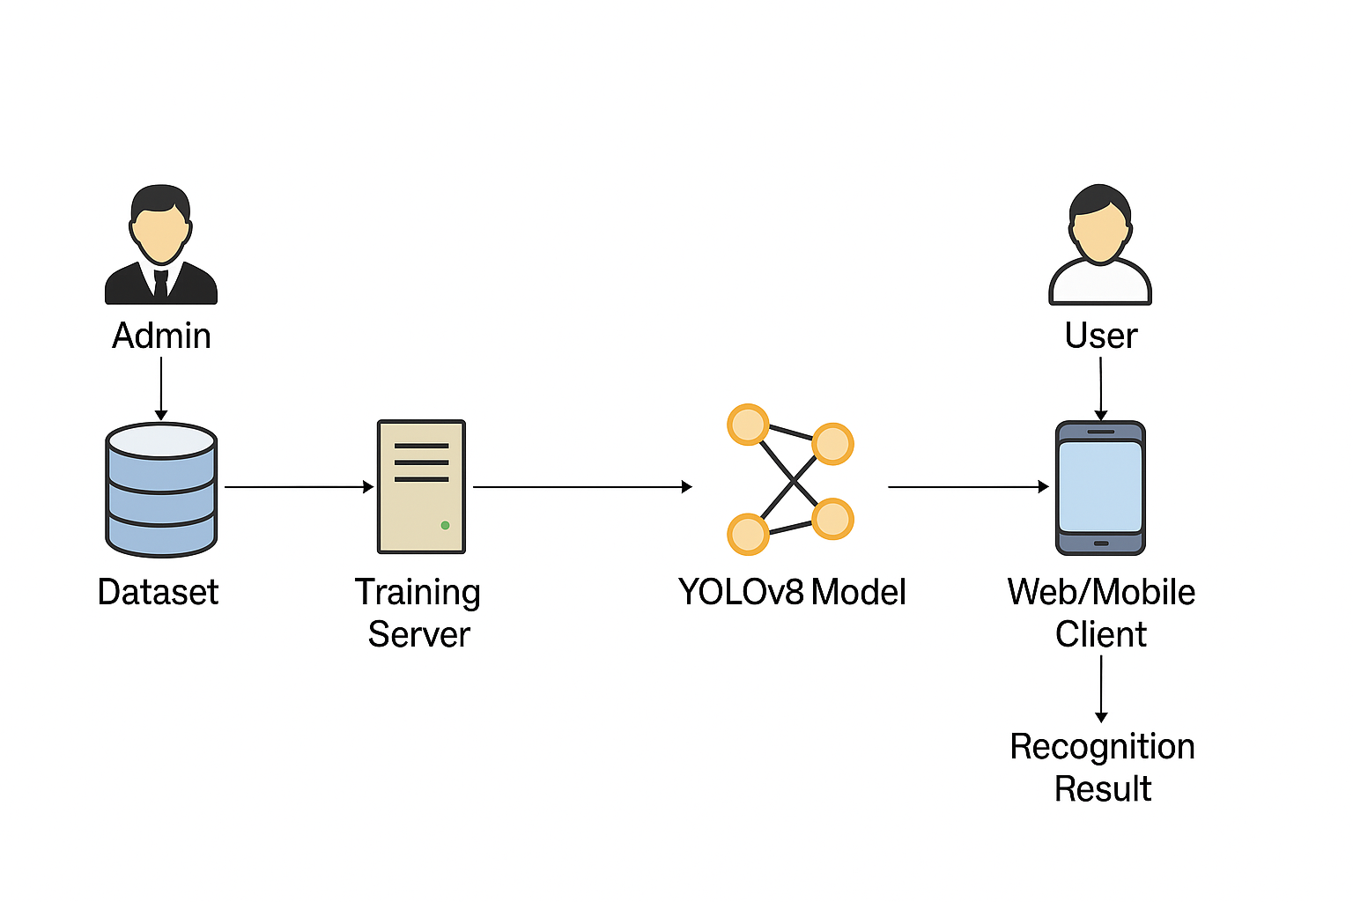
Fig: Architecture

Algorithm used
In this project, YOLOv8 is used to detect and classify human faces from different countries.
We trained YOLOv8 with a custom dataset containing facial images from seven countries — Bhutan, Brazil, Dubai, India, Korean, Nigeria, and South Africa.
- During model building, YOLOv8 is either loaded (if pre-trained weights exist) or trained using these labeled images defined in data.yaml.
- Once trained, the model learns to recognize unique facial patterns and features for each country.
- When a user uploads an image, YOLOv8 performs inference, detects the face region, and predicts which country it belongs to.
- The detection results (bounding boxes and country label) are visualized and saved as an output image for display in the web application.

PSUDO CODE
START

FUNCTION build_model():
IF trained_model_exists("runs/train/deepethno/weights/best.pt"):
LOAD YOLOv8 model with existing weights
DISPLAY "Model Loaded Successfully"
ELSE:
INITIALIZE YOLOv8 base model (yolov8n.pt)
TRAIN model using 'data.yaml' (7 country face images)
SAVE best weights to 'runs/train/deepethno/weights/best.pt'
DISPLAY "Model Trained Successfully"

FUNCTION upload_image():
RECEIVE image from user
SAVE image in 'media/uploads/'
STORE image path and username in database
DISPLAY "Image Uploaded Successfully"

FUNCTION recognize():
GET last uploaded image path from database
READ image using OpenCV
LOAD trained YOLOv8 model
RUN detection: results = model(image, conf=0.1)
EXTRACT detected class labels (country names)
FIND most common label → final_label
DRAW bounding boxes on image
SAVE result as 'Static/Result.jpg'
DISPLAY final_label and output image on webpage

END

IMPLEMENTATION
IMPLEMENTATION
- USER
- ADMIN

MODULE DESCRIPTION
ADMIN
here admin is a module should be login with the application, after successful login he can able
upload: we are uploading 7 countries faces images
{ 'Bhutan', 'Brazil', 'Dubai', 'India', 'Korean', 'Nigeriaa','South_Africa'}

Generate Model: based on countries dataset we are training yolo8 model

USER
Here user is a module should register with the application, after the successful login he can upload: Upload trained person images.
Recognize: when I clicked on recognize it will load pretrained yolo8 algorithm and send the uploaded image to model then model will recognize and logout.

SYSTEM DESIGN
DATAFLOW: Data Flow Diagram (DFD) is a graphical representation of data flow in any system. It is capable of illustrating incoming data flow, outgoing data flow and store data. The DFD depicts both incoming and outgoing data flows and provides a high-level overview of system functionality. It is a relatively simple technique to learn and use, making it accessible for both technical and non-technical stakeholders.
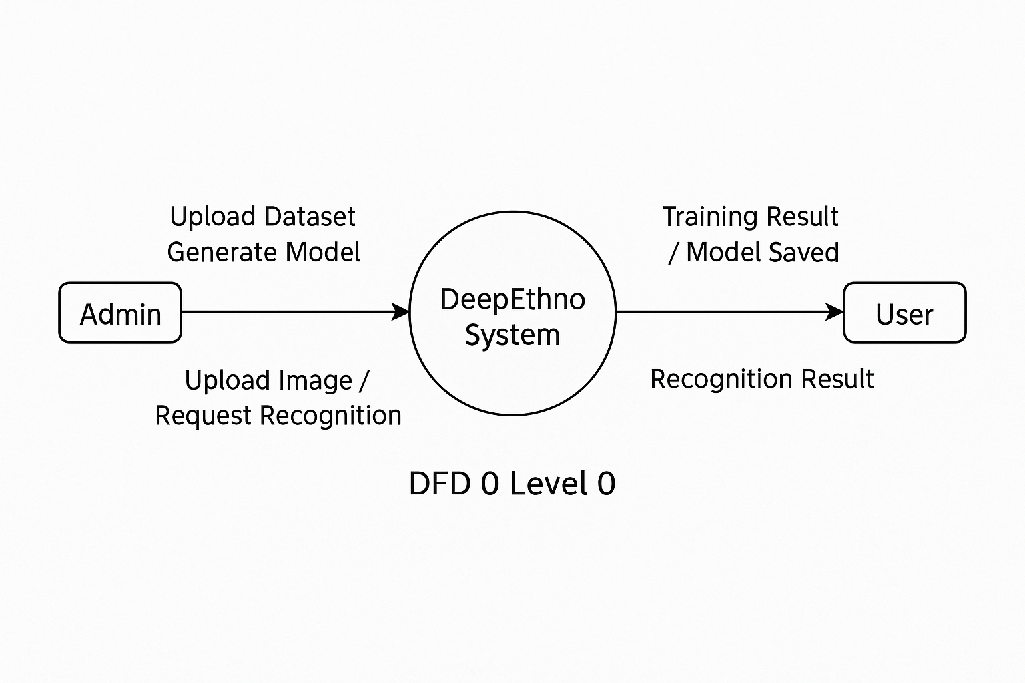

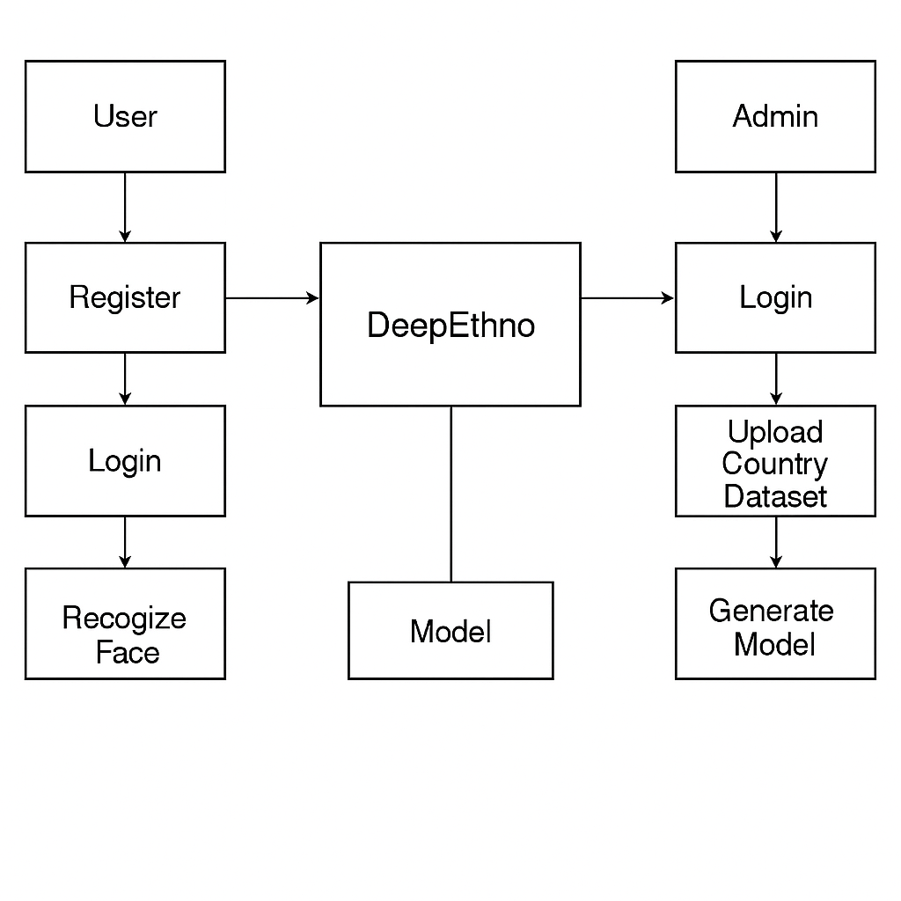
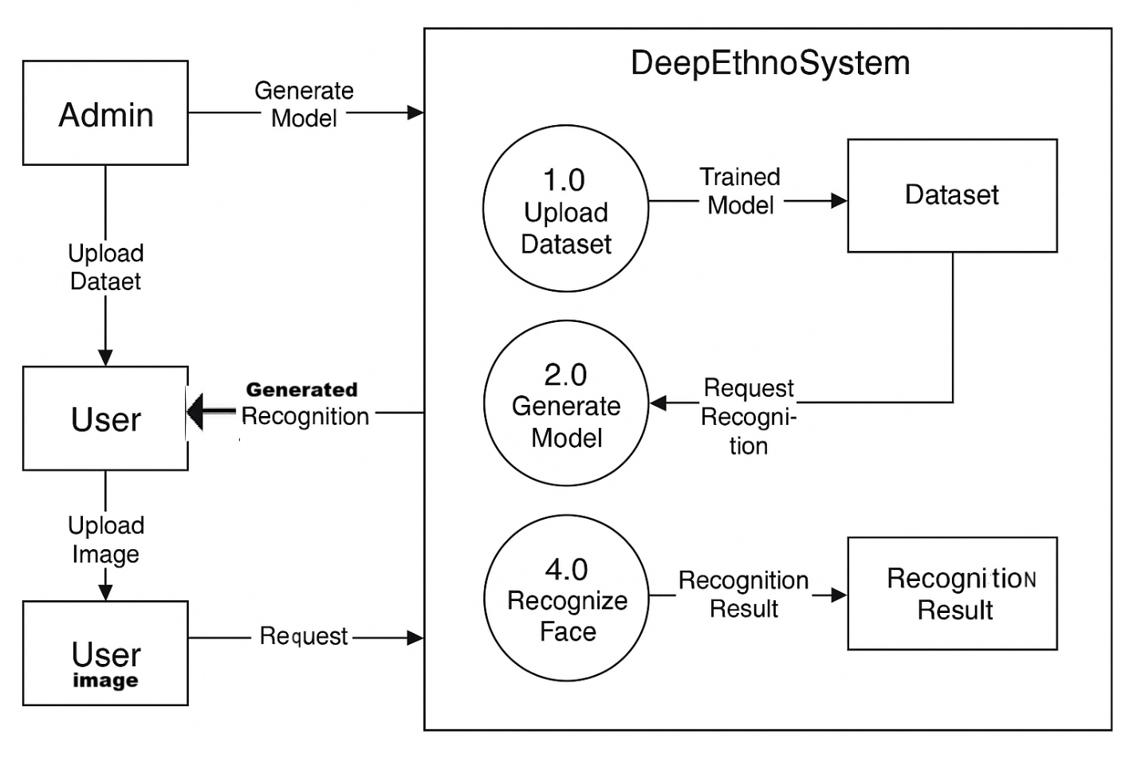

UML DIAGRAMS

UML stands for Unified Modeling Language. UML is a standardized general-purpose modeling language in the field of object-oriented software engineering. The standard is managed, and was created by, the Object Management Group.
The goal is for UML to become a common language for creating models of object oriented computer software. In its current form UML is comprised of two major components: a Meta-model and a notation. In the future, some form of method or process may also be added to; or associated with, UML.
The Unified Modeling Language is a standard language for specifying, Visualization, Constructing and documenting the artifacts of software system, as well as for business modeling and other non-software systems.
The UML represents a collection of best engineering practices that have proven successful in the modeling of large and complex systems.
The UML is a very important part of developing objects oriented software and the software development process. The UML uses mostly graphical notations to express the design of software projects.

GOALS:
The Primary goals in the design of the UML are as follows:
- Provide users a ready-to-use, expressive visual modeling Language so that they can develop and exchange meaningful models.
- Provide extendibility and specialization mechanisms to extend the core concepts.
- Be independent of particular programming languages and development process.
- Provide a formal basis for understanding the modeling language.
- Encourage the growth of OO tools market.
- Support higher level development concepts such as collaborations, frameworks, patterns and components.
- Integrate best practices.

USE CASE DIAGRAM:
A use case diagram in the Unified Modeling Language (UML) is a type of behavioral diagram defined by and created from a Use-case analysis. Its purpose is to present a graphical overview of the functionality provided by a system in terms of actors, their goals (represented as use cases), and any dependencies between those use cases. The main purpose of a use case diagram is to show what system functions are performed for which actor. Roles of the actors in the system can be depicted.

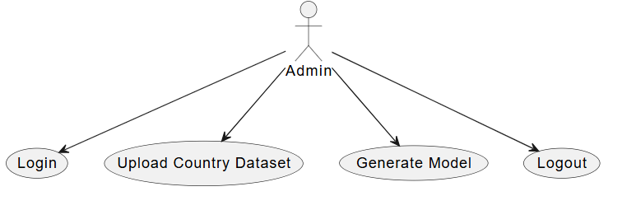

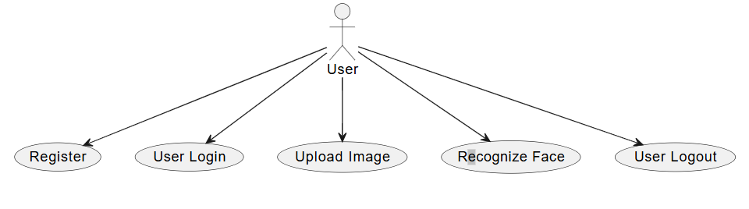

CLASS DIAGRAM:
In software engineering, a class diagram in the Unified Modeling Language (UML) is a type of static structure diagram that describes the structure of a system by showing the system's classes, their attributes, operations (or methods), and the relationships among the classes. It explains which class contains information.

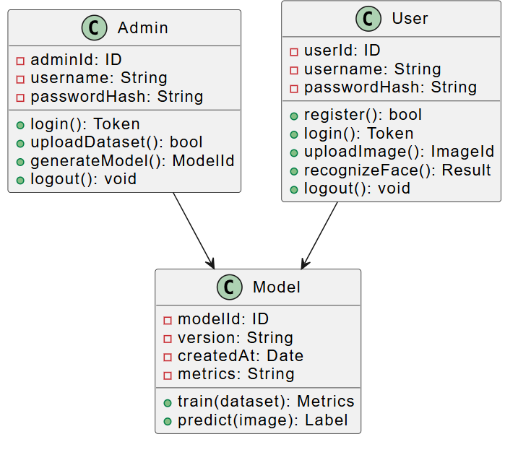

SEQUENCE DIAGRAM:
A sequence diagram in Unified Modeling Language (UML) is a kind of interaction diagram that shows how processes operate with one another and in what order. It is a construct of a Message Sequence Chart. Sequence diagrams are sometimes called event diagrams, event scenarios, and timing diagrams.

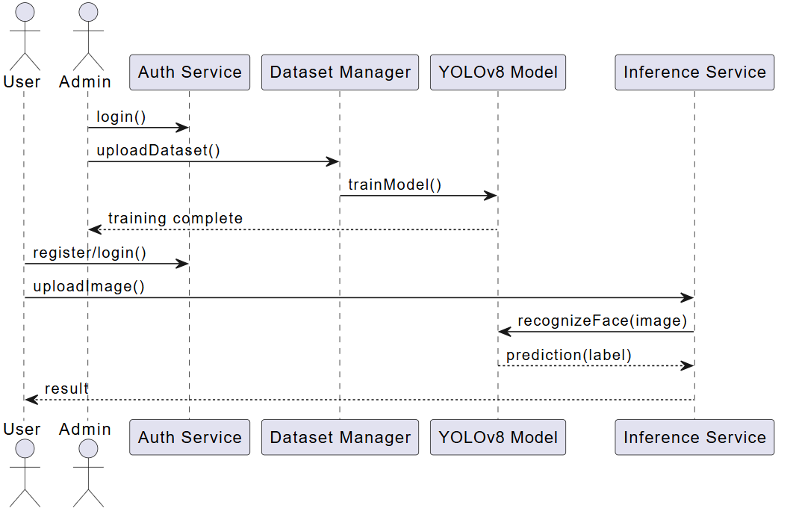

ACTIVITY: An Activity Diagram is a type of UML diagram that represents the dynamic aspects of a system. It is primarily used to model the flow of control or activities in a process, system, or use case. This diagram is particularly useful in modeling the workflow of a system and how different actions or steps are performed, helping to visualize both sequential and parallel flows.

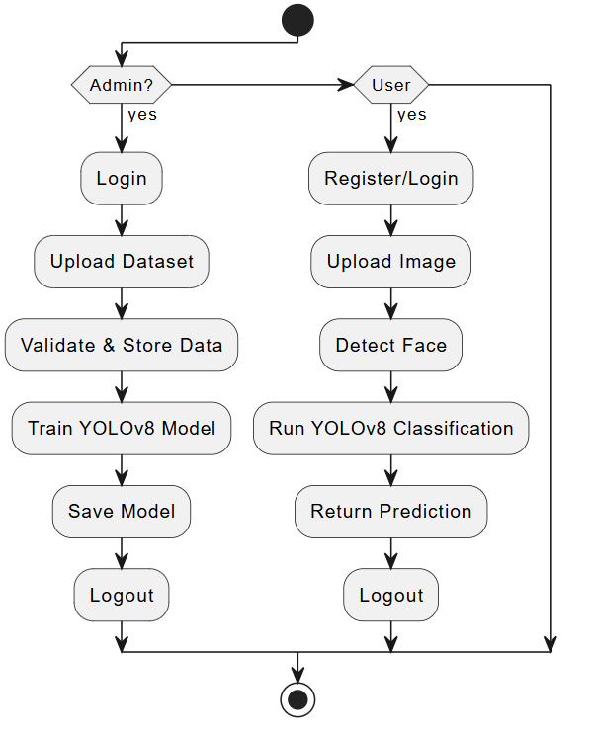
DEPLOYMENT: Deployment refers to the act of positioning something or someone in a strategic or ready state for a particular purpose, or the state of being positioned. In a military context, it means sending troops and equipment to a location for a mission, such as a war or a peaceful relief effort. In non-military contexts, such as business or software development, it can mean assigning people to a new location, spreading out a sales force, or making software available to users.

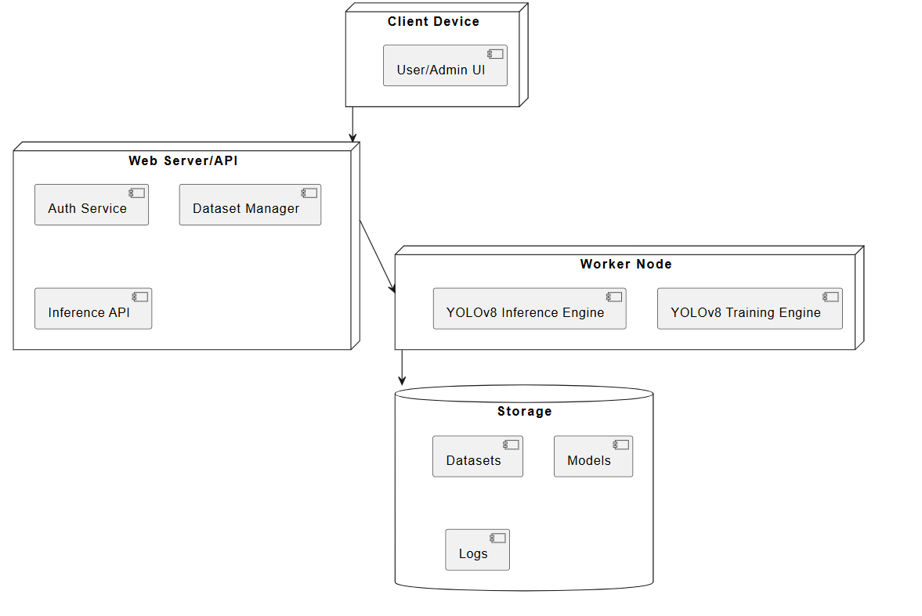
STATECHART: A statechart diagram visually models the behavior of a system or object by showing its different states (conditions or phases) and the events or conditions that trigger transitions between those states, effectively depicting the object's entire life cycle from creation to termination
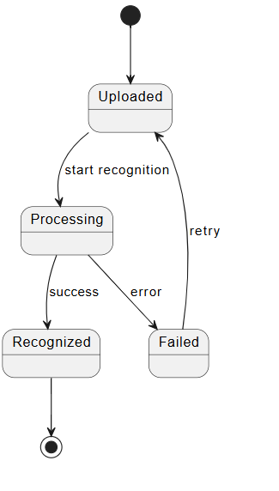
COMPONENT: A component is a fundamental part or element of a larger, more complex system, whether physical or abstract, that performs a specific function and has a defined interface. In technology, this could be a hardware device like a CPU, a software module, or even a firmware or virtual machine. In a broader sense, components are the constituent pieces that make up a whole, such as fresh fruit and vegetables being components of a healthy diet, or the specific parts and aspects that define something more complex.
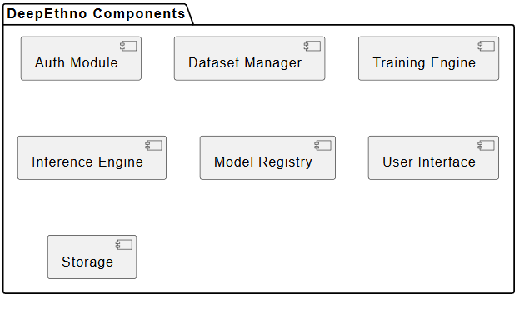

LITERATURAL SURVEY
TITLE: YOLOv8 — Models & Usage (Documentation)
AUTHORS: Ultralytics Team
ABSTRACT: The YOLOv8 documentation by Ultralytics serves as the official technical resource for understanding and applying the YOLOv8 architecture. It describes in detail the different model variants (nano, small, medium, large, x-large), their speed-versus-accuracy tradeoffs, and provides end-to-end guidance on dataset preparation, training, validation, and inference. The documentation highlights improvements such as anchor-free detection, updated backbone networks, and modular design that allow researchers to easily adapt the architecture for tasks beyond object detection, including segmentation and classification. For academic projects like DeepEthno, these resources are crucial because they enable rapid prototyping and deployment with minimal configuration while ensuring reproducibility. The documentation also emphasizes code examples and API usage, reducing the technical barrier for researchers unfamiliar with prior YOLO versions. This makes YOLOv8 particularly suitable for academic projects requiring both efficiency and ease of integration.
PUBLICATION YEAR: 2023

TITLE: Real-Time Flying Object Detection with YOLOv8
AUTHORS: D. Reis
ABSTRACT: This paper focuses on real-time detection of flying objects, such as drones and aircraft, using YOLOv8. It emphasizes the importance of lightweight architectures for time-sensitive applications where both speed and accuracy are critical. The study compares YOLOv8 with earlier YOLO variants and other real-time object detectors, demonstrating YOLOv8’s superior ability to process high-velocity targets in dynamic environments. For DeepEthno, the key insight lies in its handling of real-time processing and the emphasis on dataset augmentation to improve generalization in complex conditions. Similar principles can be applied to facial recognition and regional identification, where the model must account for variations in pose, lighting, and occlusion. The methodology also reinforces the significance of preprocessing pipelines that ensure robust feature extraction, making YOLOv8 not just an object detector but a versatile backbone for domain-specific classification.
PUBLICATION YEAR: 2023

TITLE: Running Ultralytics Object Detection and Segmentation Models in a Few Lines of Code
AUTHORS: N. Ladi
ABSTRACT: This article presents an implementation-focused approach to running YOLOv8 and other Ultralytics models using minimal Python code. By showcasing how to load pre-trained models, apply them to datasets, and perform inference in just a few lines, it reduces the technical barrier for adoption. The work demonstrates the simplicity of transferring models into custom datasets, making it highly relevant for researchers who need to build quick prototypes. For DeepEthno, this usability is critical: admins and researchers can quickly upload new datasets, retrain YOLOv8 models on country-specific faces, and deploy updated classifiers with minimal overhead. Moreover, the paper emphasizes reproducibility by promoting best practices in using model checkpoints, saving logs, and exporting results to standardized formats. This reinforces the project’s academic credibility, ensuring that models can be replicated and validated across different environments.
PUBLICATION YEAR: 2024

TITLE: Validating Privacy-Preserving Face Recognition under a Minimum Assumption
AUTHORS: Z. Zhang et al.
ABSTRACT: The paper addresses the increasing demand for privacy-preserving approaches in face recognition systems, where sensitive biometric data is often processed and stored. It introduces the concept of validating privacy-preserving systems under minimal assumptions, emphasizing the balance between preserving user confidentiality and maintaining recognition accuracy. For the DeepEthno system, which deals with regional and demographic attributes, this paper highlights important considerations for securing data and ensuring ethical compliance. The proposed frameworks, such as Map2V, allow models to be validated in a way that respects privacy constraints while still performing complex recognition tasks. This becomes critical when dealing with multi-country datasets, where cultural and legal restrictions on biometric data handling vary significantly. The paper also points out the risks of demographic profiling and underscores the importance of ensuring that such systems are not misused beyond academic contexts.
PUBLICATION YEAR: 2024

TITLE: Surveying Racial Bias in Facial Recognition: Balancing Accuracy and Fairness
AUTHORS: A. Sumsion
ABSTRACT: This comprehensive survey examines the issue of racial bias in facial recognition systems, focusing on how imbalanced datasets lead to uneven performance across demographic groups. The author discusses fairness metrics such as disparate impact, equal error rate, and per-class accuracy, and evaluates various bias mitigation strategies including dataset balancing, augmentation, and algorithmic adjustments. For DeepEthno, which attempts to classify individuals into regional categories, this survey underscores the risks of skewed accuracy if certain groups (e.g., underrepresented regions) dominate the training set. The study also explores real-world consequences of biased recognition, such as wrongful classifications and cultural insensitivity, which are particularly relevant in the context of academic research where ethical considerations must be documented. By adopting fairness evaluation techniques recommended in this survey, DeepEthno can position itself as a responsible prototype rather than a biased recognition system.
PUBLICATION YEAR: 2024

TITLE: Understanding of Facial Features in Face Perception: Insights for Computational Models
AUTHORS: Q. Zhang et al.
ABSTRACT: This paper investigates the cognitive and perceptual processes underlying human face recognition and maps these insights into computational frameworks. It discusses how different facial regions (eyes, nose, mouth, and jawline) contribute differently to recognition accuracy, providing an empirical basis for focusing on certain structural features. For DeepEthno, this is particularly valuable because regional prediction often relies on subtle morphological differences that may be overlooked by generic recognition pipelines. The paper further suggests that attention mechanisms in deep networks can be designed to mirror human visual strategies, improving interpretability and robustness. Additionally, it discusses challenges in capturing cross-cultural variations in perception, which aligns closely with the DeepEthno system’s goal of identifying multi-country regional differences.
PUBLICATION YEAR: 2024

TITLE: What is YOLOv8: An In-Depth Exploration
AUTHORS: Community Authors (arXiv preprint)
ABSTRACT: This preprint provides a deep dive into YOLOv8’s architecture, describing its anchor-free detection approach, cross-stage partial networks (CSPNet) backbone, and performance improvements compared to YOLOv5. The exploration highlights YOLOv8’s modularity and its ability to adapt to different tasks beyond detection, such as segmentation and classification. For DeepEthno, the technical details here validate why YOLOv8 is a strong choice for training a model on facial datasets — it offers higher recall, reduced false positives, and efficient inference times. The study also emphasizes training heuristics such as mosaic augmentation and label smoothing, which are beneficial in handling diverse datasets across multiple regions.
PUBLICATION YEAR: 2024

TITLE: What is YOLOv8? A Complete Guide
AUTHORS: Roboflow Team
ABSTRACT: The Roboflow guide expands on YOLOv8 by presenting implementation workflows that include dataset preprocessing, model training, hyperparameter tuning, and deployment strategies. It emphasizes compatibility with various export formats (ONNX, TensorRT, CoreML) for cross-platform deployment, making it useful for academic projects that may require demonstrations across devices. For DeepEthno, this guide is highly practical as it allows researchers to not only train models but also deploy them in a portable manner for classroom or lab use. The guide also highlights the use of data versioning and annotation tools, both of which are essential for managing multi-country facial datasets consistently.
PUBLICATION YEAR: 2024

TITLE: A Review on YOLOv8 and Its Advancements
AUTHORS: S. Mupparaju et al.
ABSTRACT: This review paper consolidates the advancements of YOLOv8 compared to earlier YOLO architectures, focusing on improvements in speed, accuracy, and versatility. It presents benchmarking studies that compare YOLOv8 with YOLOv5, Faster R-CNN, and SSD across multiple datasets. The authors analyze technical innovations like decoupled head architecture and enhanced augmentation strategies that contribute to YOLOv8’s superior performance. For DeepEthno, the insights from this paper validate the use of YOLOv8 for large-scale regional classification tasks, since its architecture supports both efficiency and accuracy. The review also predicts YOLOv8’s potential role in domains requiring fairness, interpretability, and multi-task learning, aligning with DeepEthno’s academic ambitions.
PUBLICATION YEAR: 2024

TITLE: Review of Demographic Fairness in Face Recognition
AUTHORS: Research Community (arXiv)
ABSTRACT: This survey synthesizes recent developments in ensuring demographic fairness in face recognition systems. It reviews fairness definitions, metrics, and algorithmic interventions such as adversarial debiasing, fairness-aware loss functions, and balanced data augmentation. The paper also emphasizes the ethical dimension, warning against the misuse of demographic classification in surveillance and law enforcement. For DeepEthno, the survey serves as a guiding document to ensure that the prototype is developed with ethical safeguards, transparency, and fairness reporting. It also provides academic justification for including fairness metrics alongside accuracy in evaluating the system’s performance, ensuring that biases across regional categories are explicitly documented.
PUBLICATION YEAR: 2025

SOFTWARE ENVIRONMENT
1.1 PYTHON
Python is a high-level, interpreted, interactive and object-oriented scripting language. Python is designed to be highly readable. It uses English keywords frequently where as other languages use punctuation, and it has fewer syntactical constructions than other languages.
- Python is Interpreted: Python is processed at runtime by the interpreter. You do not need to compile your program before executing it. This is similar to PERL and PHP.
- Python is Interactive: You can actually sit at a Python prompt and interact with the interpreter directly to write your programs.
- Python is Object-Oriented: Python supports Object-Oriented style or technique of programming that encapsulates code within objects.
- Python is a Beginner's Language: Python is a great language for the beginner-level programmers and supports the development of a wide range of applications from simple text processing to WWW browsers to games.

1.2 History of Python

Python was developed by Guido van Rossum in the late eighties and early nineties at the National Research Institute for Mathematics and Computer Science in the Netherlands.
Python is derived from many other languages, including ABC, Modula-3, C, C++, Algol-68, SmallTalk, and Unix shell and other scripting languages.
Python is copyrighted. Like Perl, Python source code is now available under the GNU General Public License (GPL).
Python is now maintained by a core development team at the institute, although Guido van Rossum still holds a vital role in directing its progress.

1.3 Python Features
Python's features include:
- Easy-to-learn: Python has few keywords, simple structure, and a clearly defined syntax. This allows the student to pick up the language quickly.
- Easy-to-read: Python code is more clearly defined and visible to the eyes.
- Easy-to-maintain: Python's source code is fairly easy-to-maintain.
- A broad standard library: Python's bulk of the library is very portable and cross-platform compatible on UNIX, Windows, and Macintosh.

- Interactive Mode: Python has support for an interactive mode which allows interactive testing and debugging of snippets of code.
- Portable: Python can run on a wide variety of hardware platforms and has the same interface on all platforms.
- Extendable: You can add low-level modules to the Python interpreter. These modules enable programmers to add to or customize their tools to be more efficient.
- Databases: Python provides interfaces to all major commercial databases.
- GUI Programming: Python supports GUI applications that can be created and ported to many system calls, libraries and windows systems, such as Windows MFC, Macintosh, and the X Window system of Unix.
- Scalable: Python provides a better structure and support for large programs than shell scripting.
Python has a big list of good features:
- It supports functional and structured programming methods as well as OOP.
- It can be used as a scripting language or can be compiled to byte-code for building large applications.
- It provides very high-level dynamic data types and supports dynamic type checking.
- IT supports automatic garbage collection.
- It can be easily integrated with C, C++, COM, ActiveX, CORBA, and Java.

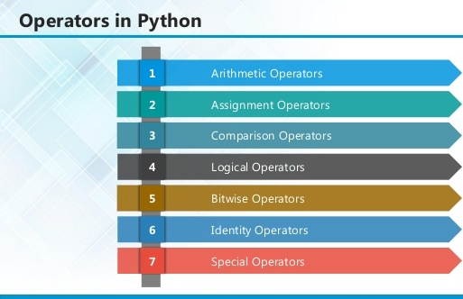

2.1 ARITHMETIC OPERATORS

Operator | Description | Example
+ Addition | Adds values on either side of the operator. | a + b = 30
- Subtraction | Subtracts right hand operand from left hand operand. | a – b = -10
* Multiplication | Multiplies values on either side of the operator | a * b = 200
/ Division | Divides left hand operand by right hand operand | b / a = 2
% Modulus | Divides left hand operand by right hand operand and returns remainder | b % a = 0
** Exponent | Performs exponential (power) calculation on operators | a**b =10 to the power 20
// | Floor Division - The division of operands where the result is the quotient in which the digits after the decimal point are removed. But if one of the operands is negative, the result is floored, i.e., rounded away from zero (towards negative infinity): | 9//2 = 4 and 9.0//2.0 = 4.0, -11//3 = -4, -11.0//3 = -4.0

2.2ASSIGNMENT OPERATOR

Operator | Description | Example
= | Assigns values from right side operands to left side operand | c = a + b assigns value of a + b into c
+= Add AND | It adds right operand to the left operand and assign the result to left operand | c += a is equivalent to c = c + a
-= Subtract AND | It subtracts right operand from the left operand and assign the result to left operand | c -= a is equivalent to c = c - a
*= Multiply AND | It multiplies right operand with the left operand and assign the result to left operand | c *= a is equivalent to c = c * a
/= Divide AND | It divides left operand with the right operand and assign the result to left operand | c /= a is equivalent to c = c / ac /= a is equivalent to c = c / a

%= Modulus AND | It takes modulus using two operands and assign the result to left operand | c %= a is equivalent to c = c % a
**= Exponent AND | Performs exponential (power) calculation on operators and assign value to the left operand | c **= a is equivalent to c = c ** a
//= Floor Division | It performs floor division on operators and assign value to the left operand | c //= a is equivalent to c = c // a

2.3 IDENTITY OPERATOR

Operator | Description | Example
is | Evaluates to true if the variables on either side of the operator point to the same object and false otherwise. | x is y, here is results in 1 if id(x) equals id(y).
is not | Evaluates to false if the variables on either side of the operator point to the same object and true otherwise. | x is not y, here is not results in 1 if id(x) is not equal to id(y

2.4 COMPARISON OPERATOR

Operator | Description | Example
& Binary AND | Operator copies a bit to the result if it exists in both operands | (a & b) (means 0000 1100)
| Binary OR | It copies a bit if it exists in either operand. | (a | b) = 61 (means 0011 1101)
^ Binary XOR | It copies the bit if it is set in one operand but not both. | (a ^ b) = 49 (means 0011 0001)
~ Binary Ones Complement | It is unary and has the effect of 'flipping' bits. | (~a ) = -61 (means 1100 0011 in 2's complement form due to a signed binary number.
<< Binary Left Shift | The left operands value is moved left by the number of bits specified by the right operand. | a << 2 = 240 (means 1111 0000)
>> Binary Right Shift | The left operands value is moved right by the number of bits specified by the right operand. | a >> 2 = 15 (means 0000 1111)

2.5 LOGICAL OPERATOR

Operator | Description | Example
and Logical AND | If both the operands are true then condition becomes true. | (a and b) is true.
or Logical OR | If any of the two operands are non-zero then condition becomes true. | (a or b) is true.
not Logical NOT | Used to reverse the logical state of its operand. | Not(a and b) is false.

2.6 Membership Operators

Operator | Description | Example
in | Evaluates to true if it finds a variable in the specified sequence and false otherwise. | x in y, here in results in a 1 if x is a member of sequence y.
not in | Evaluates to true if it does not finds a variable in the specified sequence and false otherwise. | x not in y, here not in results in a 1 if x is not a member of sequence y.

Python Operators Precedence
Operator | Description
** | Exponentiation (raise to the power)
~ + - | Complement, unary plus and minus (method names for the last two are +@ and -@)
* / % // | Multiply, divide, modulo and floor division
+ - | Addition and subtraction
>> << | Right and left bitwise shift
& | Bitwise 'AND'
^ | | Bitwise exclusive `OR' and regular `OR'
<= < > >= | Comparison operators
<> == != | Equality operators
= %= /= //= -= += *= **= | Assignment operators
is is not | Identity operators
in not in | Membership operators
not or and | Logical operators

3.1 LIST
The list is a most versatile data type available in Python which can be written as a list of comma-separated values (items) between square brackets. Important thing about a list is that items in a list need not be of the same type.
Creating a list is as simple as putting different comma-separated values between square brackets. For example −
list1 = ['physics', 'chemistry', 1997, 2000];
list2 = [1, 2, 3, 4, 5 ];
list3 = ["a", "b", "c", "d"]

Basic List Operations
Lists respond to the + and * operators much like strings; they mean concatenation and repetition here too, except that the result is a new list, not a string.
Python Expression | Results | Description
len([1, 2, 3]) | 3 | Length
[1, 2, 3] + [4, 5, 6] | [1, 2, 3, 4, 5, 6] | Concatenation
['Hi!'] * 4 | ['Hi!', 'Hi!', 'Hi!', 'Hi!'] | Repetition
3 in [1, 2, 3] | True | Membership
for x in [1, 2, 3]: print x, | 1 2 3 | Iteration

Built-in List Functions & Methods:
Python includes the following list functions −
SN | Function with Description
1 | cmp(list1, list2)  Compares elements of both lists.
2 | len(list)  Gives the total length of the list.
3 | max(list)  Returns item from the list with max value.
4 | min(list)  Returns item from the list with min value.
5 | list(seq)  Converts a tuple into list.

Python includes following list methods
SN | Methods with Description
1 | list.append(obj)  Appends object obj to list
2 | list.count(obj)  Returns count of how many times obj occurs in list
3 | list. extend(seq)  Appends the contents of seq to list
4 | list.index(obj)  Returns the lowest index in list that obj appears
5 | list.insert(index, obj)  Inserts object obj into list at offset index
6 | list.pop(obj=list[-1])  Removes and returns last object or obj from list
7 | list.remove(obj)  Removes object obj from list
8 | list.reverse()  Reverses objects of list in place
9 | list.sort([func])  Sorts objects of list, use compare function if given

3.2 TUPLES
A tuple is a sequence of immutable Python objects. Tuples are sequences, just like lists. The differences between tuples and lists are, the tuples cannot be changed unlike lists and tuples use parentheses, whereas lists use square brackets.
Creating a tuple is as simple as putting different comma-separated values. Optionally we can put these comma-separated values between parentheses also. For example −
tup1 = ('physics', 'chemistry', 1997, 2000);
tup2 = (1, 2, 3, 4, 5 );
tup3 = "a", "b", "c", "d";
The empty tuple is written as two parentheses containing nothing −
tup1 = ();
To write a tuple containing a single value you have to include a comma, even though there is only one value −
tup1 = (50,);
Like string indices, tuple indices start at 0, and they can be sliced, concatenated, and so on.

Accessing Values in Tuples:
To access values in tuple, use the square brackets for slicing along with the index or indices to obtain value available at that index. For example –
tup1 = ('physics', 'chemistry', 1997, 2000);
tup2 = (1, 2, 3, 4, 5, 6, 7 );
print "tup1[0]: ", tup1[0]
print "tup2[1:5]: ", tup2[1:5]
When the code is executed, it produces the following result −
tup1[0]: physics
tup2[1:5]: [2, 3, 4, 5]

Updating Tuples:
Tuples are immutable which means you cannot update or change the values of tuple elements. We are able to take portions of existing tuples to create new tuples as the following example demonstrates −

tup1 = (12, 34.56);
tup2 = ('abc', 'xyz');
tup3 = tup1 + tup2;
print tup3
When the above code is executed, it produces the following result −
(12, 34.56, 'abc', 'xyz')

Delete Tuple Elements
Removing individual tuple elements is not possible. There is, of course, nothing wrong with putting together another tuple with the undesired elements discarded.
To explicitly remove an entire tuple, just use the del statement. For example:
tup = ('physics', 'chemistry', 1997, 2000);
print tup
del tup;
print "After deleting tup : "
print tup

Basic Tuples Operations:
Python Expression | Results | Description
len((1, 2, 3)) | 3 | Length
(1, 2, 3) + (4, 5, 6) | (1, 2, 3, 4, 5, 6) | Concatenation
('Hi!',) * 4 | ('Hi!', 'Hi!', 'Hi!', 'Hi!') | Repetition
3 in (1, 2, 3) | True | Membership
for x in (1, 2, 3): print x, | 1 2 3 | Iteration

Built-in Tuple Functions
SN | Function with Description
1 | cmp(tuple1, tuple2):Compares elements of both tuples.
2 | len(tuple):Gives the total length of the tuple.
3 | max(tuple):Returns item from the tuple with max value.
4 | min(tuple):Returns item from the tuple with min value.
5 | tuple(seq):Converts a list into tuple.

3.2 DICTIONARY
Each key is separated from its value by a colon (:), the items are separated by commas, and the whole thing is enclosed in curly braces. An empty dictionary without any items is written with just two curly braces, like this: {}.
Keys are unique within a dictionary while values may not be. The values of a dictionary can be of any type, but the keys must be of an immutable data type such as strings, numbers, or tuples.

Accessing Values in Dictionary:
To access dictionary elements, you can use the familiar square brackets along with the key to obtain its value. Following is a simple example −
dict = {'Name': 'Zara', 'Age': 7, 'Class': 'First'}

print "dict['Name']: ", dict['Name']
print "dict['Age']: ", dict['Age']
Result –
dict['Name']: Zara
dict['Age']: 7

Updating Dictionary
We can update a dictionary by adding a new entry or a key-value pair, modifying an existing entry, or deleting an existing entry as shown below in the simple example −
dict = {'Name': 'Zara', 'Age': 7, 'Class': 'First'}

dict['Age'] = 8; # update existing entry
dict['School'] = "DPS School"; # Add new entry
print "dict['Age']: ", dict['Age']
print "dict['School']: ", dict['School']
Result −
dict['Age']: 8
dict['School']: DPS School

Delete Dictionary Elements
We can either remove individual dictionary elements or clear the entire contents of a dictionary. You can also delete entire dictionary in a single operation.
To explicitly remove an entire dictionary, just use the del statement. Following is a simple example –
dict = {'Name': 'Zara', 'Age': 7, 'Class': 'First'}

del dict['Name']; # remove entry with key 'Name'
dict.clear(); # remove all entries in dict
del dict ; # delete entire dictionary

print "dict['Age']: ", dict['Age']
print "dict['School']: ", dict['School']

Built-in Dictionary Functions & Methods –
Python includes the following dictionary functions −
SN | Function with Description
1 | cmp(dict1, dict2)  Compares elements of both dict.
2 | len(dict)  Gives the total length of the dictionary. This would be equal to the number of items in the dictionary.
3 | str(dict)  Produces a printable string representation of a dictionary
4 | type(variable)  Returns the type of the passed variable. If passed variable is dictionary, then it would return a dictionary type.

Python includes following dictionary methods −
SN | Methods with Description
1 | dict.clear():Removes all elements of dictionary dict
2 | dict. Copy():Returns a shallow copy of dictionary dict
3 | dict.fromkeys():Create a new dictionary with keys from seq and values set to value.
4 | dict.get(key, default=None):For key key, returns value or default if key not in dictionary
5 | dict.has_key(key):Returns true if key in dictionary dict, false otherwise
6 | dict.items():Returns a list of dict's (key, value) tuple pairs
7 | dict.keys():Returns list of dictionary dict's keys
8 | dict.setdefault(key, default=None):Similar to get(), but will set dict[key]=default if key is not already in dict
9 | dict.update(dict2):Adds dictionary dict2's key-values pairs to dict
10 | dict.values():Returns list of dictionary dict's values

A function is a block of organized, reusable code that is used to perform a single, related action. Functions provide better modularity for your application and a high degree of code reusing. Python gives you many built-in functions like print(), etc. but you can also create your own functions. These functions are called user-defined functions.

Defining a Function
Simple rules to define a function in Python.
- Function blocks begin with the keyword def followed by the function name and parentheses ( ( ) ).
- Any input parameters or arguments should be placed within these parentheses. You can also define parameters inside these parentheses.
- The first statement of a function can be an optional statement - the documentation string of the function or docstring.
- The code block within every function starts with a colon (:) and is indented.
- The statement return [expression] exits a function, optionally passing back an expression to the caller. A return statement with no arguments is the same as return None.
def functionname( parameters ):
"function_docstring"
function_suite
return [expression]

Calling a Function
Defining a function only gives it a name, specifies the parameters that are to be included in the function and structures the blocks of code.Once the basic structure of a function is finalized, you can execute it by calling it from another function or directly from the Python prompt. Following is the example to call printme() function −
# Function definition is here
def printme( str ):
"This prints a passed string into this function"
print str
return;
# Now you can call printme function
printme("I'm first call to user defined function!")
printme("Again second call to the same function")
When the above code is executed, it produces the following result −
I'm first call to user defined function!
Again second call to the same function

Function Arguments
You can call a function by using the following types of formal arguments:
- Required arguments
- Keyword arguments
- Default arguments
- Variable-length arguments

Scope of Variables
All variables in a program may not be accessible at all locations in that program. This depends on where you have declared a variable.
The scope of a variable determines the portion of the program where you can access a particular identifier. There are two basic scopes of variables in Python −
Global variables Local variables

DJANGO
Django is a high-level Python Web framework that encourages rapid development and clean, pragmatic design. Built by experienced developers, it takes care of much of the hassle of Web development, so you can focus on writing your app without needing to reinvent the wheel. It’s free and open source.
Django's primary goal is to ease the creation of complex, database-driven websites. Django emphasizes reusability and "pluggability" of components, rapid development, and the principle of don't repeat yourself. Python is used throughout, even for settings files and data models.
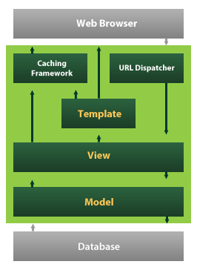
Django also provides an optional administrative create, read, update and delete interface that is generated dynamically through introspection and configured via admin models

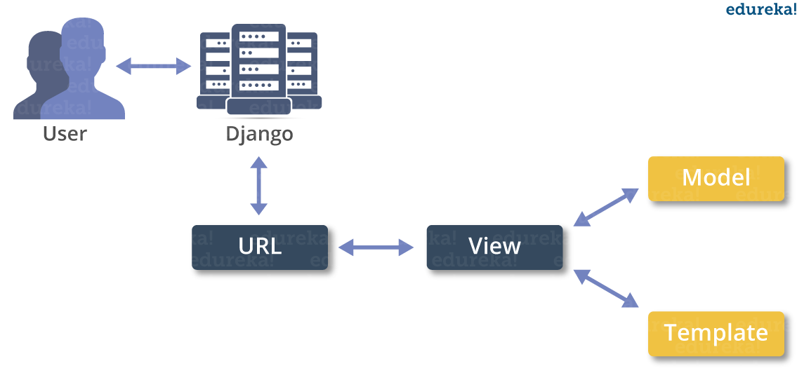
MACHINE LEARNING
- What is Machine Learning
- Machine Learning is the science (and art) of programming computers so they can learn from data.
- Machine Learning is a step into the direction of artificial intelligence (AI).
- Machine Learning is a program that analyses data and learns to predict the outcome.
- Machine learning is a growing technology which enables computers to learn automatically from past data.
- Machine learning uses various algorithms for building mathematical models and making predictions using historical data or information. Currently, it is being used for various tasks such as image recognition, speech recognition, email filtering etc..
How does Machine Learning work
- A Machine Learning system learns from historical data, builds the prediction models, and whenever it receives new data, predicts the output for it.
- The accuracy of predicted output depends upon the amount of data, as the huge amount of data helps to build a better model which predicts the output more accurately.
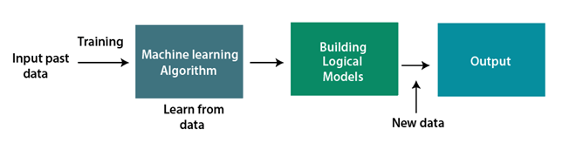
Features of Machine Learning
- Machine learning uses data to detect various patterns in a given dataset.
- It can learn from past data and improve automatically.
- Machine learning is much similar to data mining as it also deals with the huge amount of the data.
What is Train/Test
Train/Test is a method to measure the accuracy of your model.
It is called Train/Test because you split the the data set into two sets: a training set and a testing set.
- 80% for training, and 20% for testing.
- You train the model using the training set.
- You test the model using the testing set.
- Train the model means create the model.
- Test the model means test the accuracy of the model.
Classification of Machine Learning
At a broad level, machine learning can be classified into three types:
- Supervised learning
- Unsupervised learning
- Reinforcement learning

INPUT AND OUTPUT DESIGN
INPUT DESIGN
The input design is the link between the information system and the user. It comprises the developing specification and procedures for data preparation and those steps are necessary to put transaction data in to a usable form for processing can be achieved by inspecting the computer to read data from a written or printed document or it can occur by having people keying the data directly into the system. The design of input focuses on controlling the amount of input required, controlling the errors, avoiding delay, avoiding extra steps and keeping the process simple. The input is designed in such a way so that it provides security and ease of use with retaining the privacy. Input Design considered the following things:
- What data should be given as input?
- How the data should be arranged or coded?
- The dialog to guide the operating personnel in providing input.
- Methods for preparing input validations and steps to follow when error occur.

OBJECTIVES
1.Input Design is the process of converting a user-oriented description of the input into a computer-based system. This design is important to avoid errors in the data input process and show the correct direction to the management for getting correct information from the computerized system.
2. It is achieved by creating user-friendly screens for the data entry to handle large volume of data. The goal of designing input is to make data entry easier and to be free from errors. The data entry screen is designed in such a way that all the data manipulates can be performed. It also provides record viewing facilities.
3.When the data is entered it will check for its validity. Data can be entered with the help of screens. Appropriate messages are provided as when needed so that the user will not be in maize of instant. Thus the objective of input design is to create an input layout that is easy to follow

OUTPUT DESIGN
A quality output is one, which meets the requirements of the end user and presents the information clearly. In any system results of processing are communicated to the users and to other system through outputs. In output design it is determined how the information is to be displaced for immediate need and also the hard copy output. It is the most important and direct source information to the user. Efficient and intelligent output design improves the system’s relationship to help user decision-making.
1. Designing computer output should proceed in an organized, well thought out manner; the right output must be developed while ensuring that each output element is designed so that people will find the system can use easily and effectively. When analysis design computer output, they should Identify the specific output that is needed to meet the requirements.
2. Select methods for presenting information.
3. Create document, report, or other formats that contain information produced by the system.
The output form of an information system should accomplish one or more of the following objectives.
- Convey information about past activities, current status or projections of the
- Future.
- Signal important events, opportunities, problems, or warnings.
- Trigger an action.
- Confirm an action.

SYSTEM STUDY
FEASIBILITY STUDY
The feasibility of the project is analyzed in this phase and business proposal is put forth with a very general plan for the project and some cost estimates. During system analysis the feasibility study of the proposed system is to be carried out. This is to ensure that the proposed system is not a burden to the company. For feasibility analysis, some understanding of the major requirements for the system is essential.
THREE KEY CONSIDERATIONS INVOLVED IN THE FEASIBILITY ANALYSIS ARE,
- ECONOMICAL FEASIBILITY
- TECHNICAL FEASIBILITY
- SOCIAL FEASIBILITY
ECONOMICAL FEASIBILITY
This study is carried out to check the economic impact that the system will have on the organization. The amount of fund that the company can pour into the research and development of the system is limited. The expenditures must be justified. Thus the developed system as well within the budget and this was achieved because most of the technologies used are freely available. Only the customized products had to be purchased.

TECHNICAL FEASIBILITY
This study is carried out to check the technical feasibility, that is, the technical requirements of the system. Any system developed must not have a high demand on the available technical resources. This will lead to high demands on the available technical resources. This will lead to high demands being placed on the client. The developed system must have a modest requirement, as only minimal or null changes are required for implementing this system.

SOCIAL FEASIBILITY
The aspect of study is to check the level of acceptance of the system by the user. This includes the process of training the user to use the system efficiently. The user must not feel threatened by the system, instead must accept it as a necessity. The level of acceptance by the users solely depends on the methods that are employed to educate the user about the system and to make him familiar with it. His level of confidence must be raised so that he is also able to make some constructive criticism, which is welcomed, as he is the final user of the system.

SYSTEM TEST
The purpose of testing is to discover errors. Testing is the process of trying to discover every conceivable fault or weakness in a work product. It provides a way to check the functionality of components, sub assemblies, assemblies and/or a finished product It is the process of exercising software with the intent of ensuring that the Software system meets its requirements and user expectations and does not fail in an unacceptable manner. There are various types of test. Each test type addresses a specific testing requirement.

TYPES OF TESTS

Unit testing
Unit testing involves the design of test cases that validate that the internal program logic is functioning properly, and that program inputs produce valid outputs. All decision branches and internal code flow should be validated. It is the testing of individual software units of the application .it is done after the completion of an individual unit before integration. This is a structural testing, that relies on knowledge of its construction and is invasive. Unit tests perform basic tests at component level and test a specific business process, application, and/or system configuration. Unit tests ensure that each unique path of a business process performs accurately to the documented specifications and contains clearly defined inputs and expected results.

Integration testing
Integration tests are designed to test integrated software components to determine if they actually run as one program. Testing is event driven and is more concerned with the basic outcome of screens or fields. Integration tests demonstrate that although the components were individually satisfaction, as shown by successfully unit testing, the combination of components is correct and consistent. Integration testing is specifically aimed at exposing the problems that arise from the combination of components.

Functional test

Functional tests provide systematic demonstrations that functions tested are available as specified by the business and technical requirements, system documentation, and user manuals.
Functional testing is centered on the following items:
Valid Input : identified classes of valid input must be accepted.
Invalid Input : identified classes of invalid input must be rejected.
Functions : identified functions must be exercised.
Output : identified classes of application outputs must be exercised.
Systems/Procedures : interfacing systems or procedures must be invoked.
Organization and preparation of functional tests is focused on requirements, key functions, or special test cases. In addition, systematic coverage pertaining to identify Business process flows; data fields, predefined processes, and successive processes must be considered for testing. Before functional testing is complete, additional tests are identified and the effective value of current tests is determined.

System Test
System testing ensures that the entire integrated software system meets requirements. It tests a configuration to ensure known and predictable results. An example of system testing is the configuration oriented system integration test. System testing is based on process descriptions and flows, emphasizing pre-driven process links and integration points.

White Box Testing
White Box Testing is a testing in which in which the software tester has knowledge of the inner workings, structure and language of the software, or at least its purpose. It is purpose. It is used to test areas that cannot be reached from a black box level.

Black Box Testing

Black Box Testing is testing the software without any knowledge of the inner workings, structure or language of the module being tested. Black box tests, as most other kinds of tests, must be written from a definitive source document, such as specification or requirements document, such as specification or requirements document. It is a testing in which the software under test is treated, as a black box .you cannot “see” into it. The test provides inputs and responds to outputs without considering how the software works.
Unit Testing
Unit testing is usually conducted as part of a combined code and unit test phase of the software lifecycle, although it is not uncommon for coding and unit testing to be conducted as two distinct phases.
Test strategy and approach
Field testing will be performed manually and functional tests will be written in detail.
Test objectives
- All field entries must work properly.
- Pages must be activated from the identified link.
- The entry screen, messages and responses must not be delayed.

Features to be tested
- Verify that the entries are of the correct format
- No duplicate entries should be allowed
- All links should take the user to the correct page.

Integration Testing
Software integration testing is the incremental integration testing of two or more integrated software components on a single platform to produce failures caused by interface defects.
The task of the integration test is to check that components or software applications, e.g. components in a software system or – one step up – software applications at the company level – interact without error.
Test Results: All the test cases mentioned above passed successfully. No defects encountered.

Acceptance Testing
User Acceptance Testing is a critical phase of any project and requires significant participation by the end user. It also ensures that the system meets the functional requirements.
Test Results: All the test cases mentioned above passed successfully. No defects encountered.

SAMPLE CODE

Views.py
from django.shortcuts import render
from django.core.files.storage import FileSystemStorage
import os
from django.conf import settings
import cv2
import pymysql
import traceback, sys, os
from ultralytics import YOLO
import matplotlib
matplotlib.use('Agg')
import matplotlib.pyplot as plt

def index(request):
return render(request, 'index.html')

def admin_login(request):
return render(request, 'admin/admin_login.html')

def login_action(request):
username = request.POST.get('username')
password = request.POST.get('password')
if username == 'Admin' and password == 'Admin':
return render(request, 'admin/admin_home.html')
else:
context = {'msg': 'Login failed..!'}
return render(request, 'admin/admin_login.html', context)

def admin_home(request):
return render(request, 'admin/admin_home.html')

def logout(request):
return render(request, 'index.html')

def upload_dataset(request):
return render(request, 'admin/upload_dataset.html')

def upload_action(request):
global dataset
dataset = "dataset\\"
context = {'data':"Dataset Uploaded Successfully...!!"}
return render(request, "admin/upload_dataset.html", context)

global train, valid

def generate_image(request):
global train, valid
train = "train"
valid = "valid"

context = {'train':len(train), 'validation':len(valid)}
return render(request, 'admin/generate_image.html', context)

global model

def build_model(request):
global train, valid, model

if os.path.exists('runs/train/deepethno/weights/best.pt'):
# Load the trained model
model = YOLO("runs/train/deepethno/weights/best.pt") # Ensure path is correct

context = {"data": " Yolo Model Loaded ,Successfully...!!"}
return render(request, 'admin/build_model.html', context)
else:
model = YOLO('yolov8n.pt')

model.train(data='data.yaml', epochs=50,
imgsz=640,
batch=8,
name='deepethno',
project='runs/train'
)

context = {"data": " Model Generated Successfully.."}
return render(request, 'admin/build_model.html', context)

def user_registration(request):
return render(request, 'user/user_registration.html')

def registration_action(request):
username = request.POST['username']
email = request.POST['email']
password = request.POST['password']
confirm_password = request.POST['confirm_password']

if password != confirm_password:
return render(request, 'user/user_registration.html', {'msg': 'Passwords do not match'})

con = pymysql.connect(
host="localhost",
user="root",
password="root",
database="deepethno",
charset="utf8"
)
cur = con.cursor()
cur.execute("SELECT * FROM user WHERE username=%s OR email=%s", (username, email))
existing_user = cur.fetchone()

if existing_user:
con.close()
return render(request, 'user/user_registration.html', {'msg': 'Username or Email already exists!'})

cur.execute(
"INSERT INTO user (username, email, password) VALUES (%s, %s, %s)",
(username, email, password)
)
con.commit()
con.close()
return render(request, 'user/user_registration.html', {'msg': 'Registration Successful!'})

def user_login(request):
return render(request, 'user/user_login.html')

def user_login_action(request):
username = request.POST['username']
password = request.POST['password']
con = pymysql.connect(host="localhost", user="root", password="root",
database="deepethno", charset='utf8')
cur = con.cursor()
cur.execute("SELECT * FROM user WHERE username=%s AND password=%s", (username, password))
user = cur.fetchone()
con.close()

if user:
request.session['username']=username
return render(request, 'user/user_home.html', {'username': username})
else:
return render(request, 'user/user_login.html', {'msg': 'Invalid username or password'})

def user_home(request):
return render(request, 'user/user_home.html')

def upload_image(request):
return render(request, 'user/upload_image.html')

SCREENSHOTS
Index
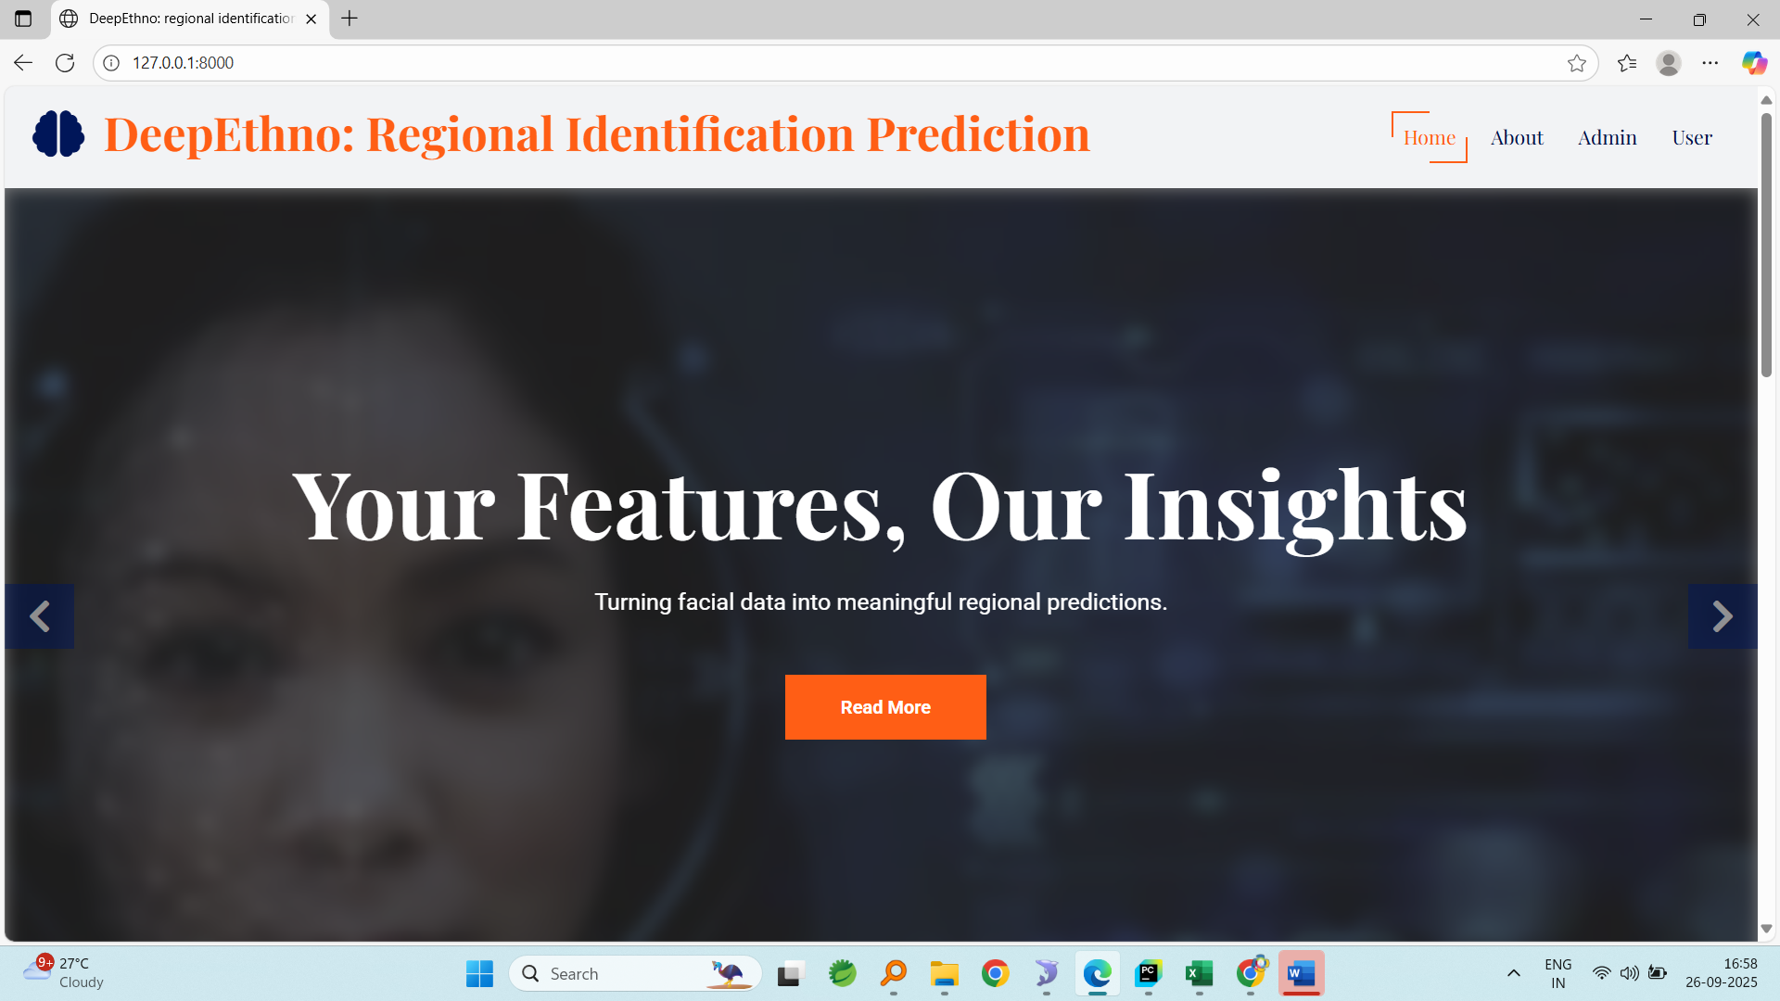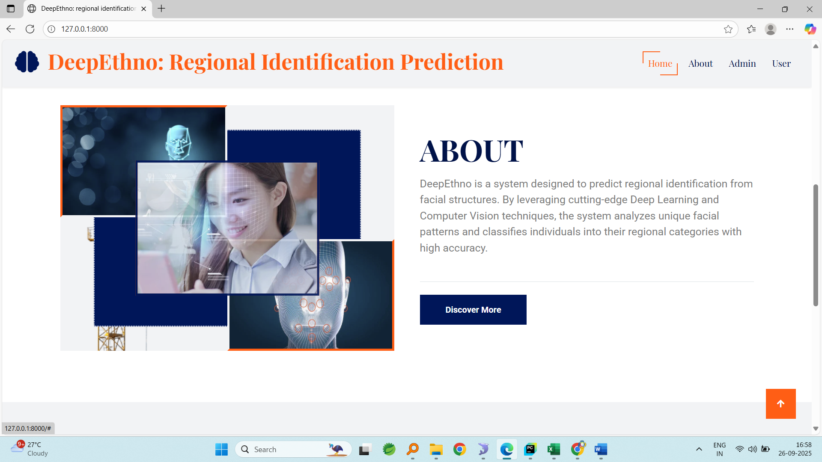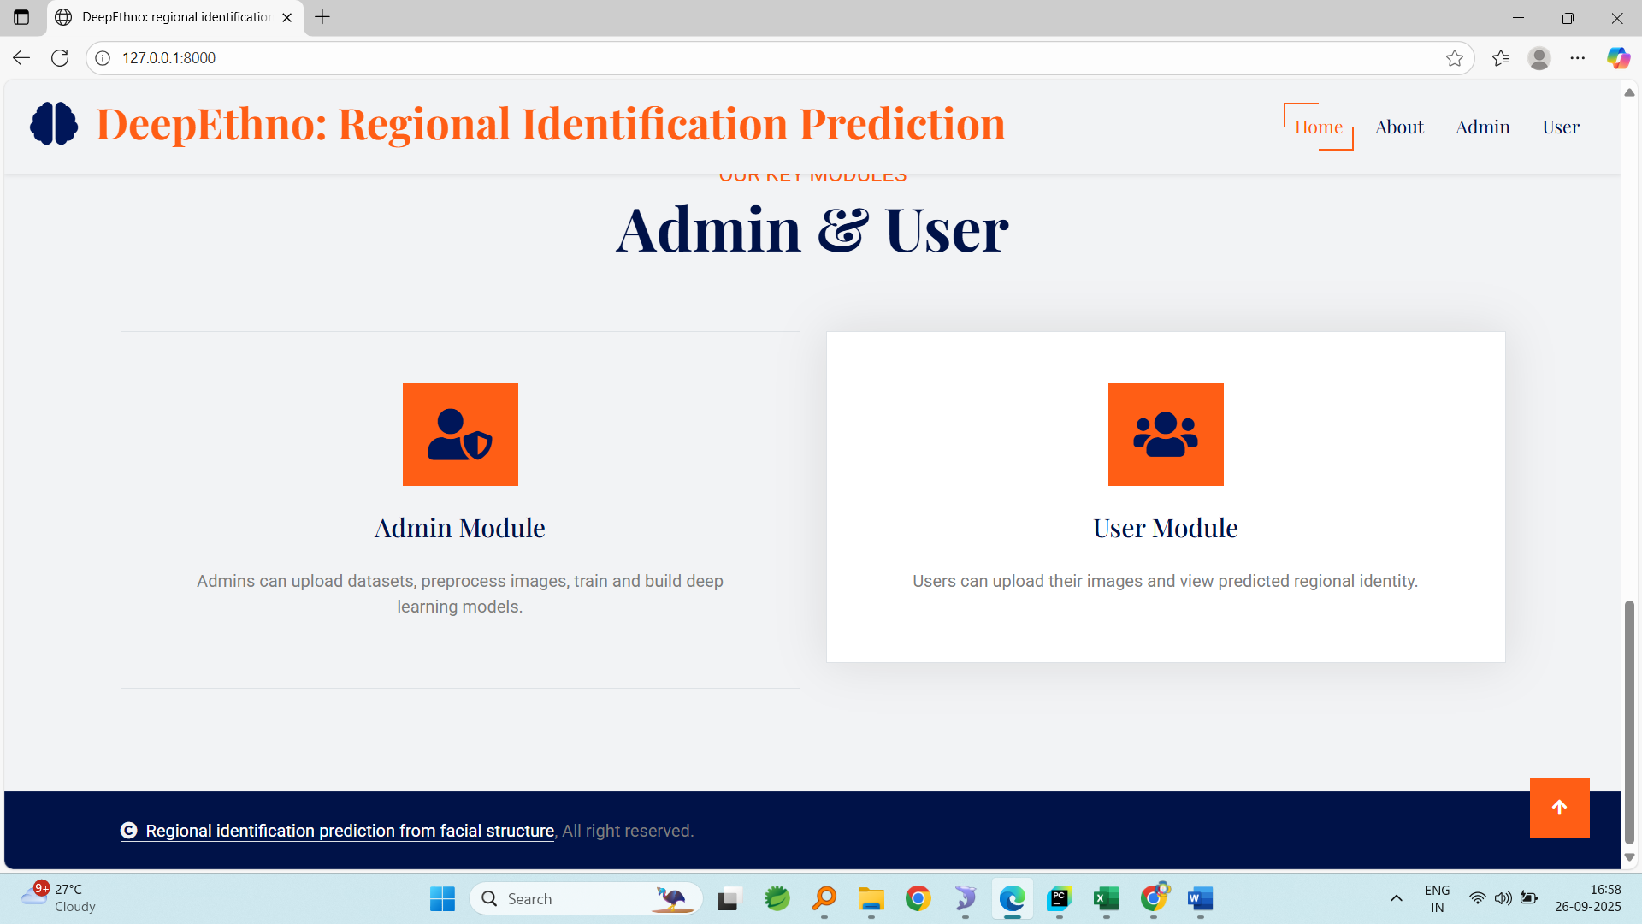
About
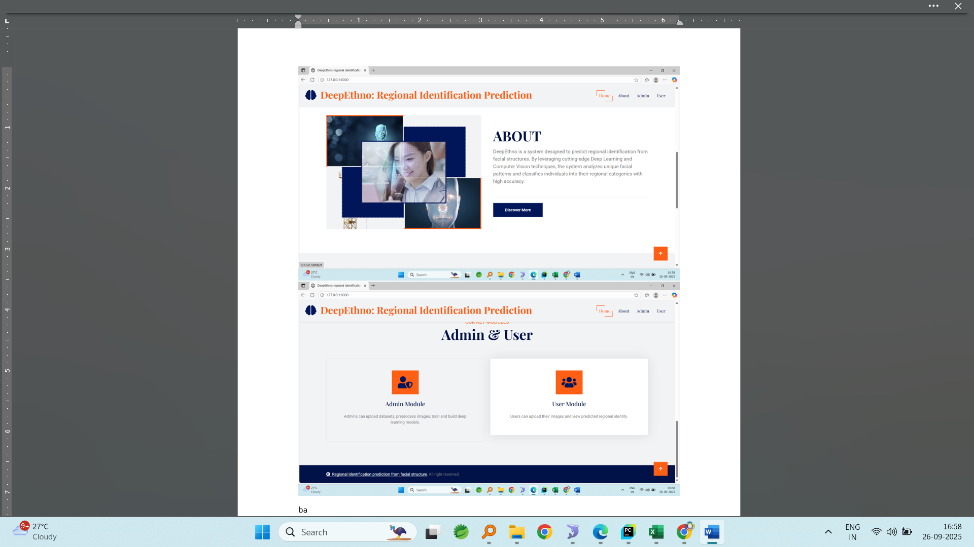
Admin login
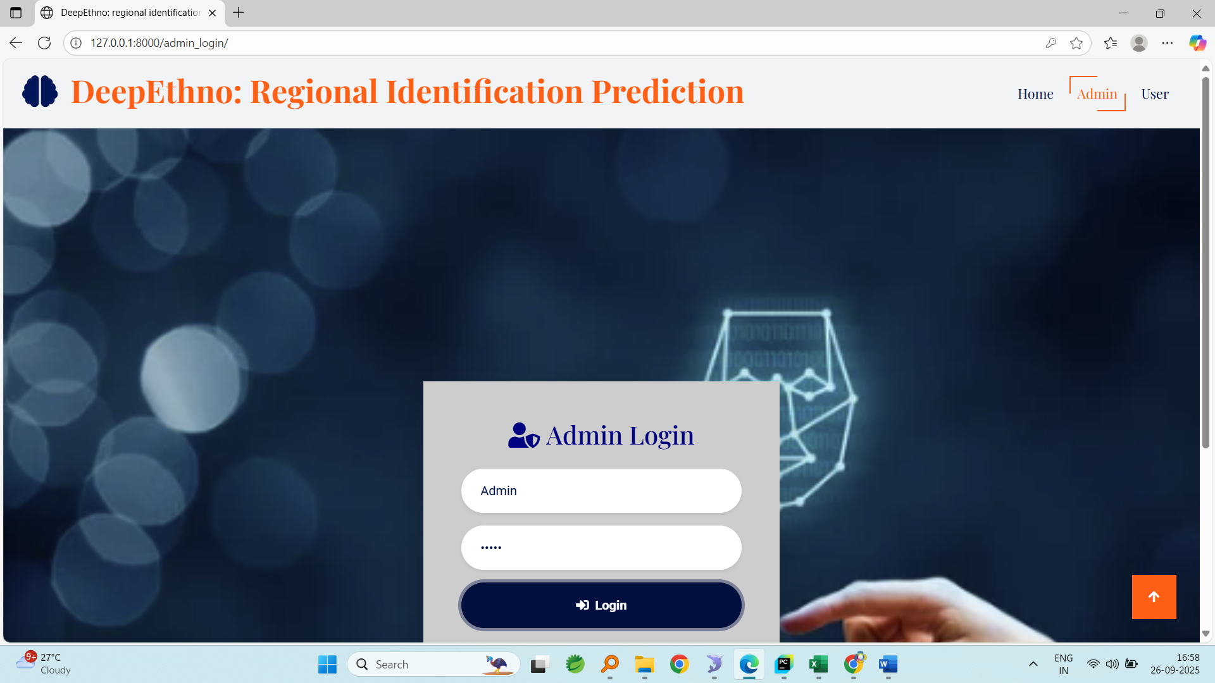
Admin home
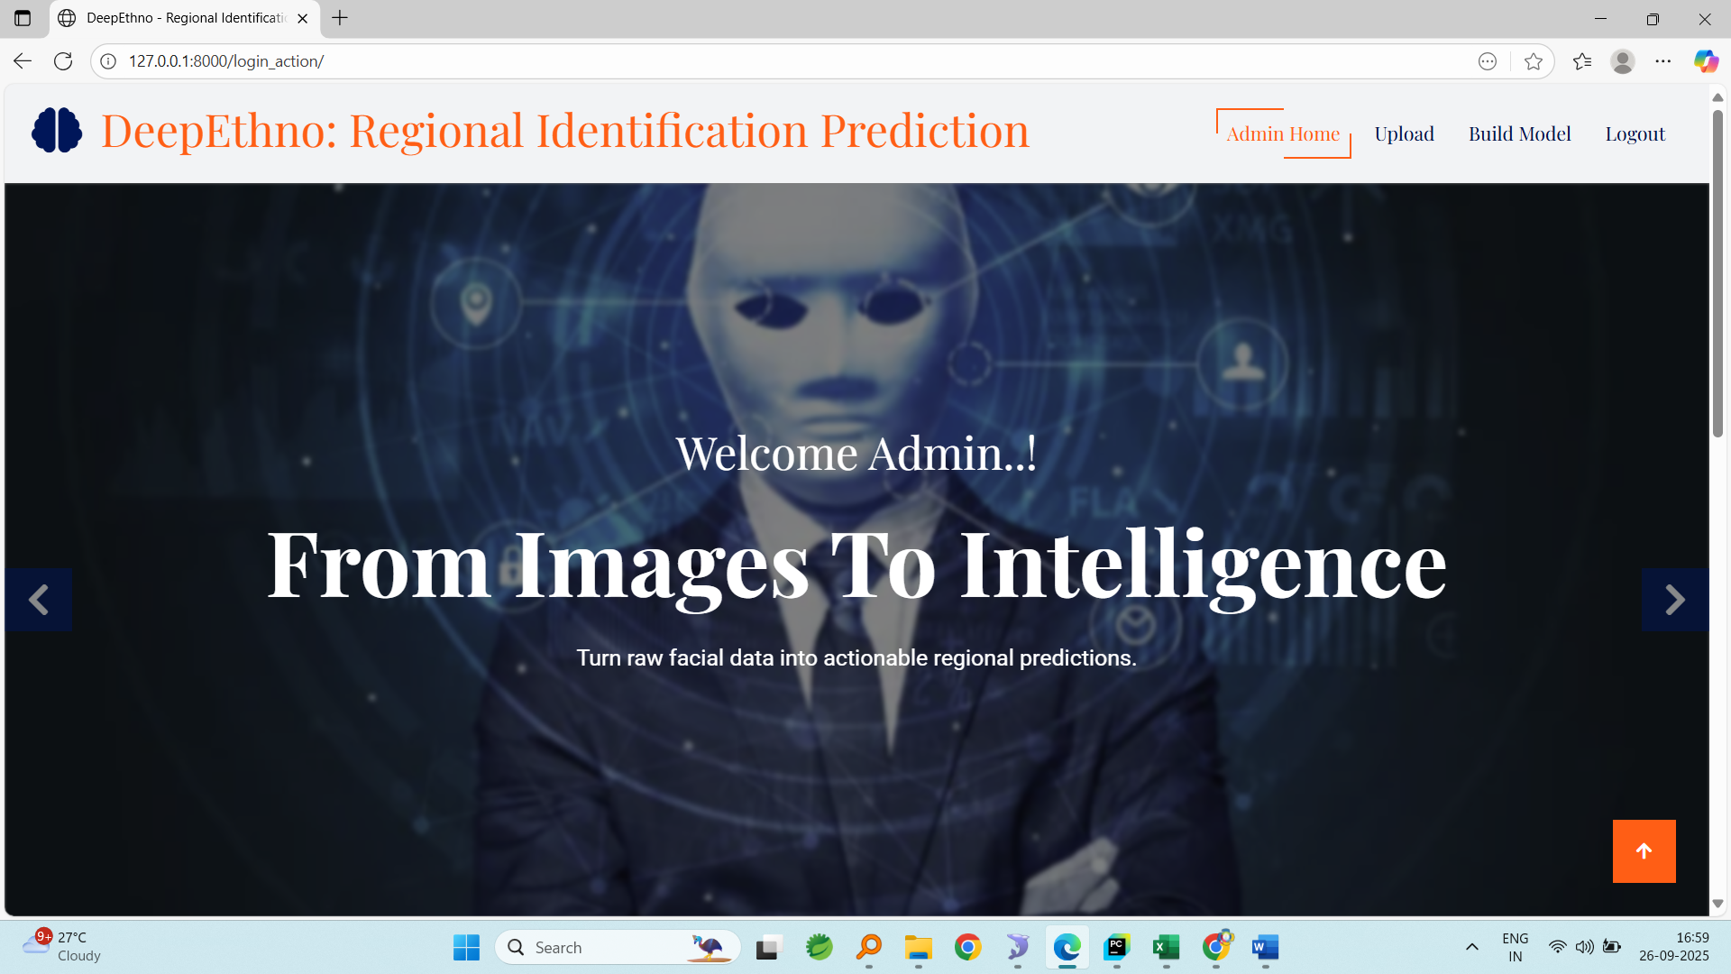
Uploading dataset
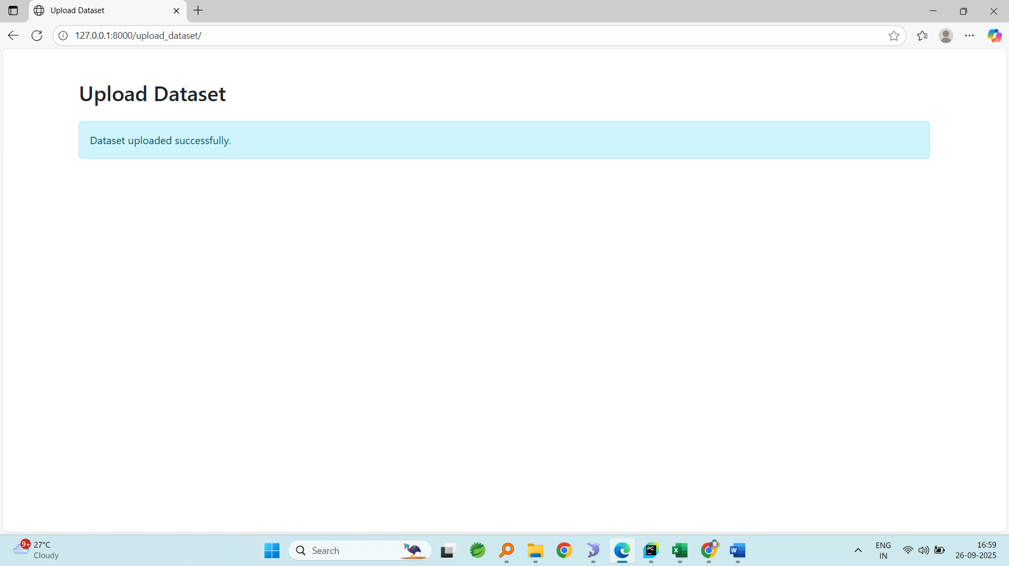
Model loaded
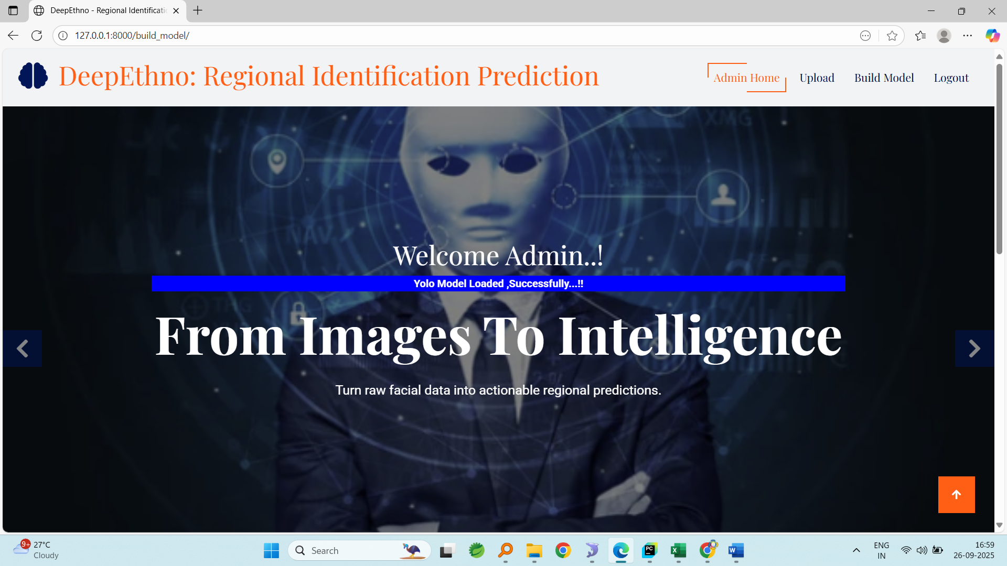
Registration page
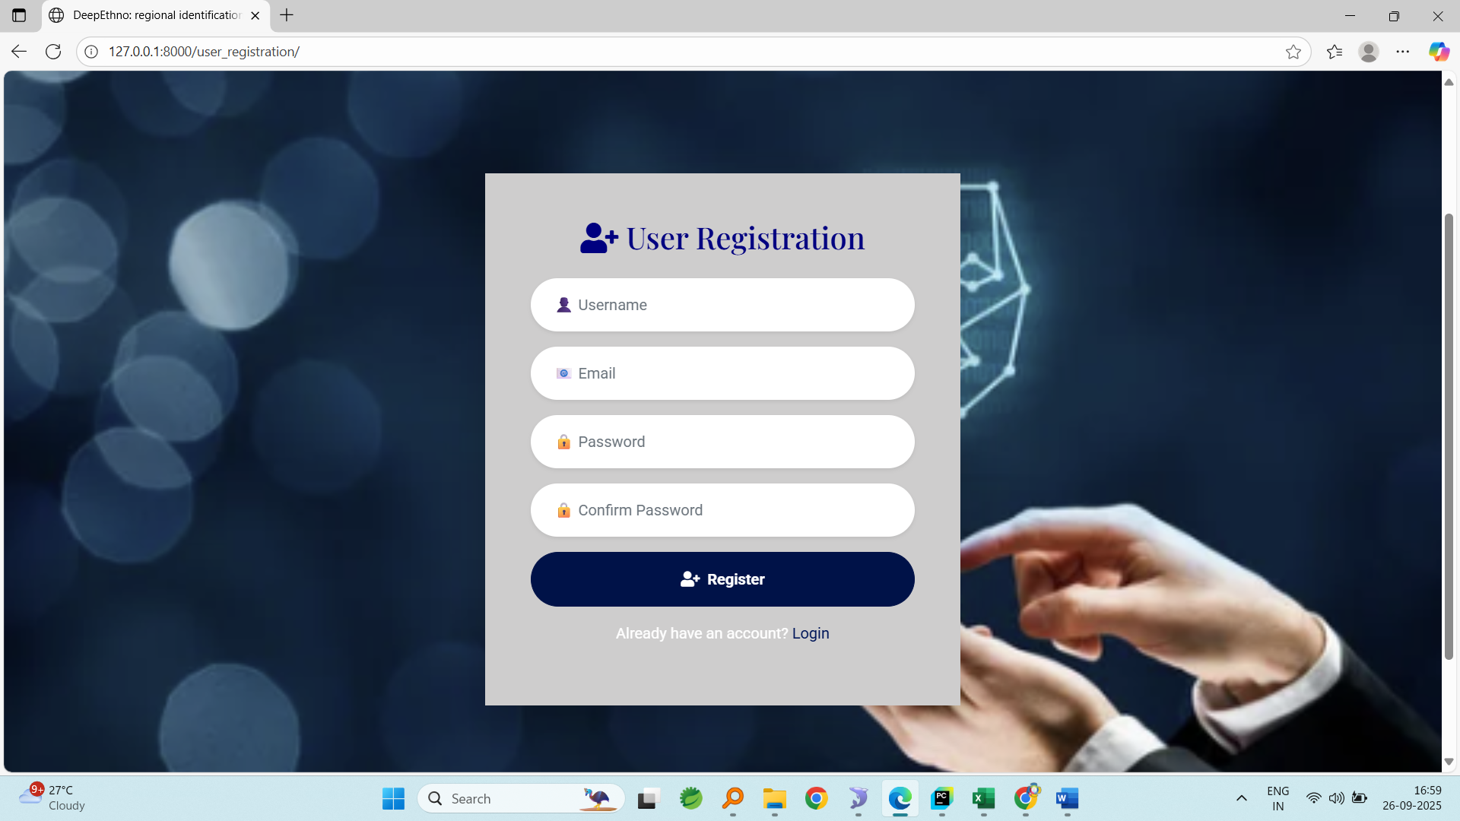login page
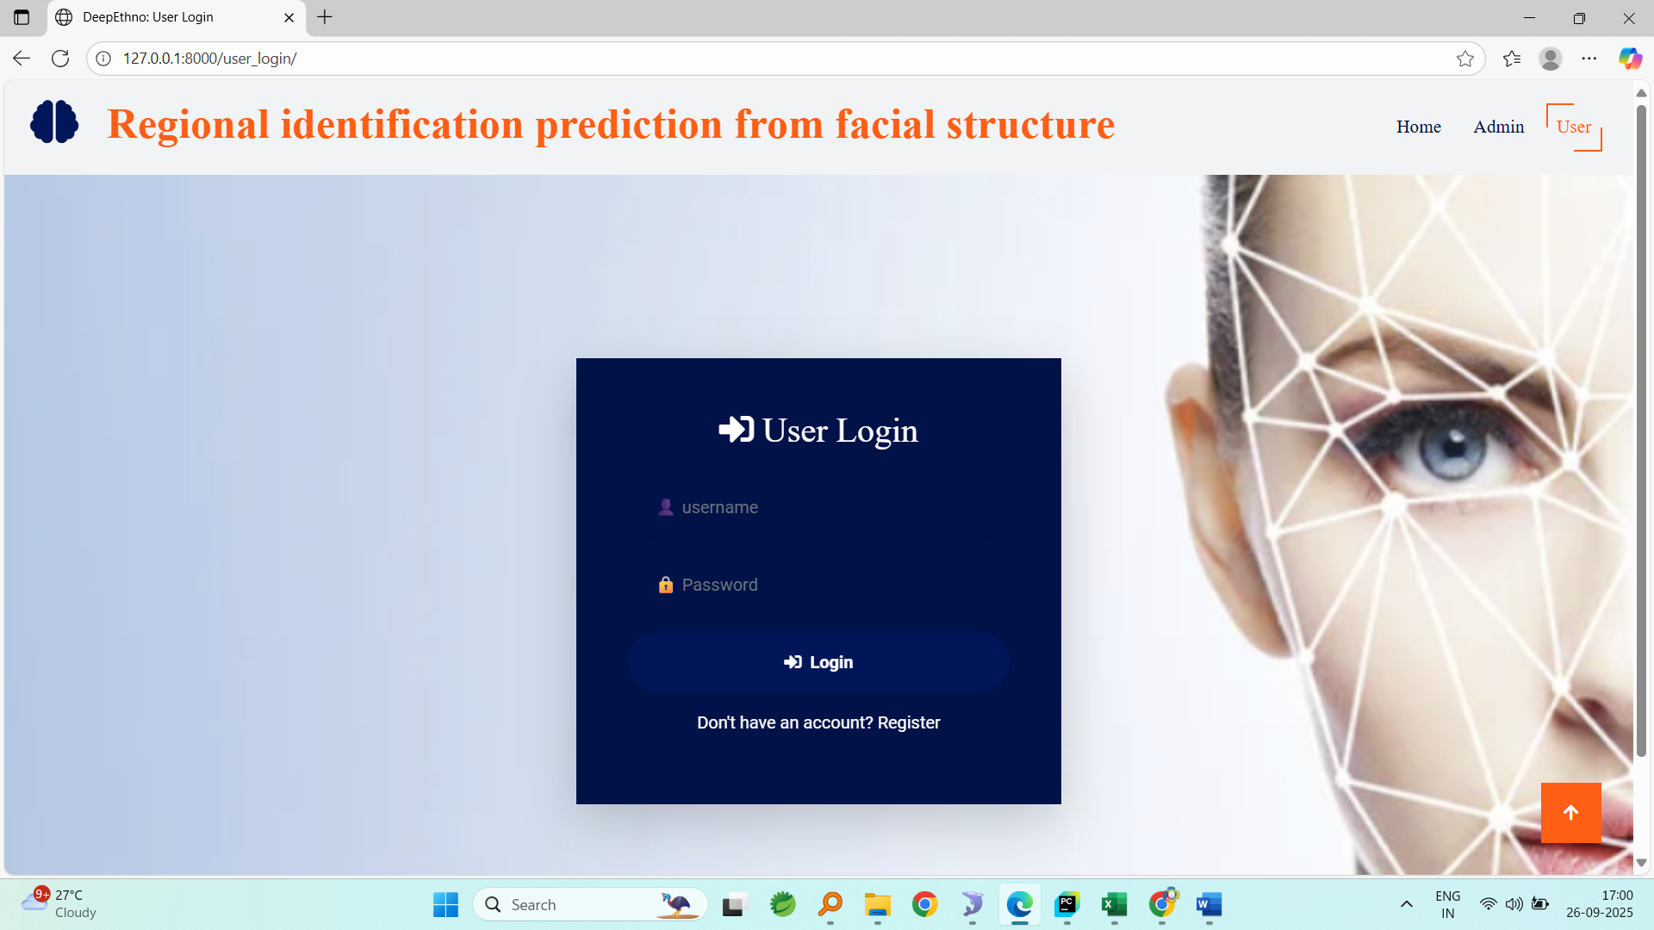
Userhome
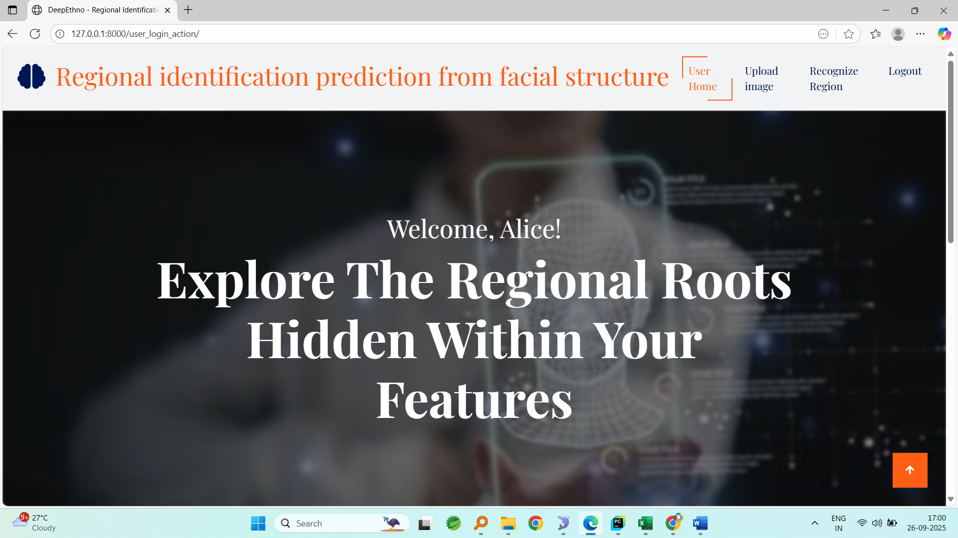
Uploading image
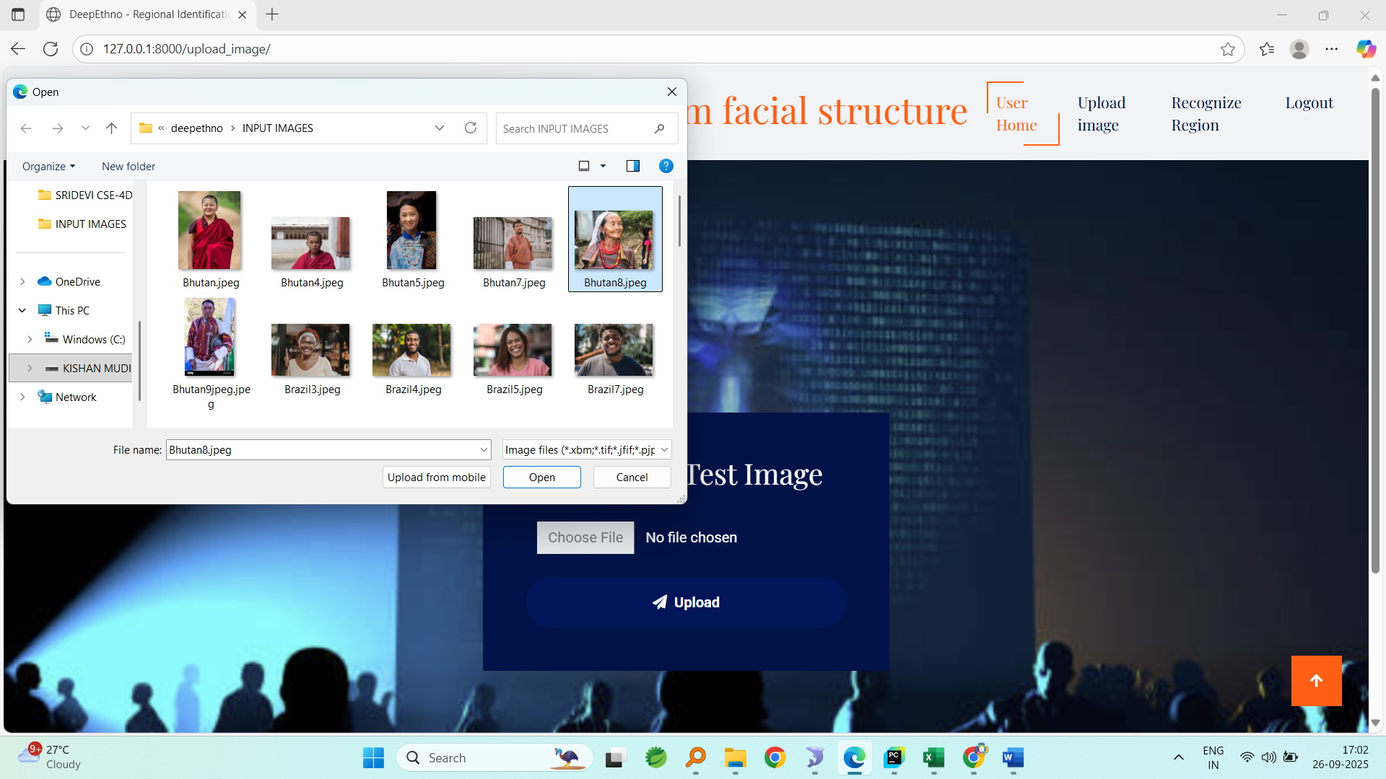
Finger print uploaded
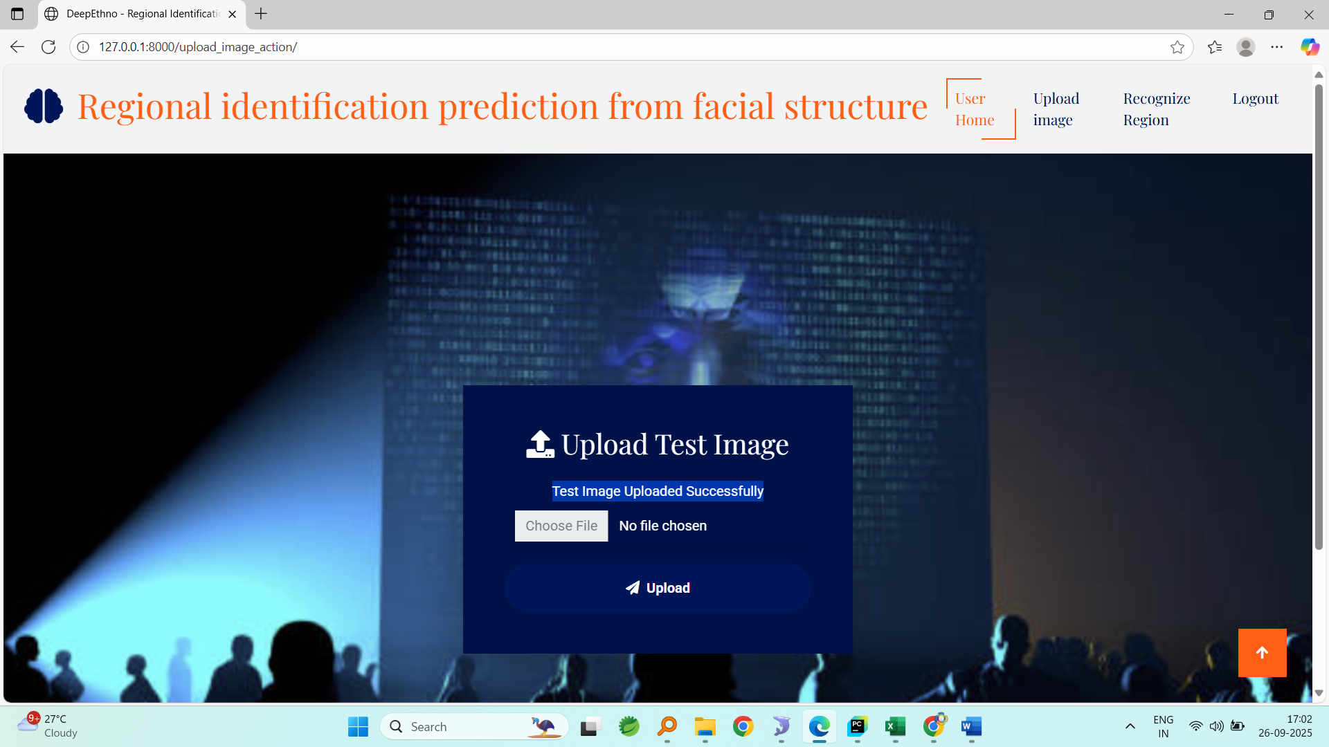
Result
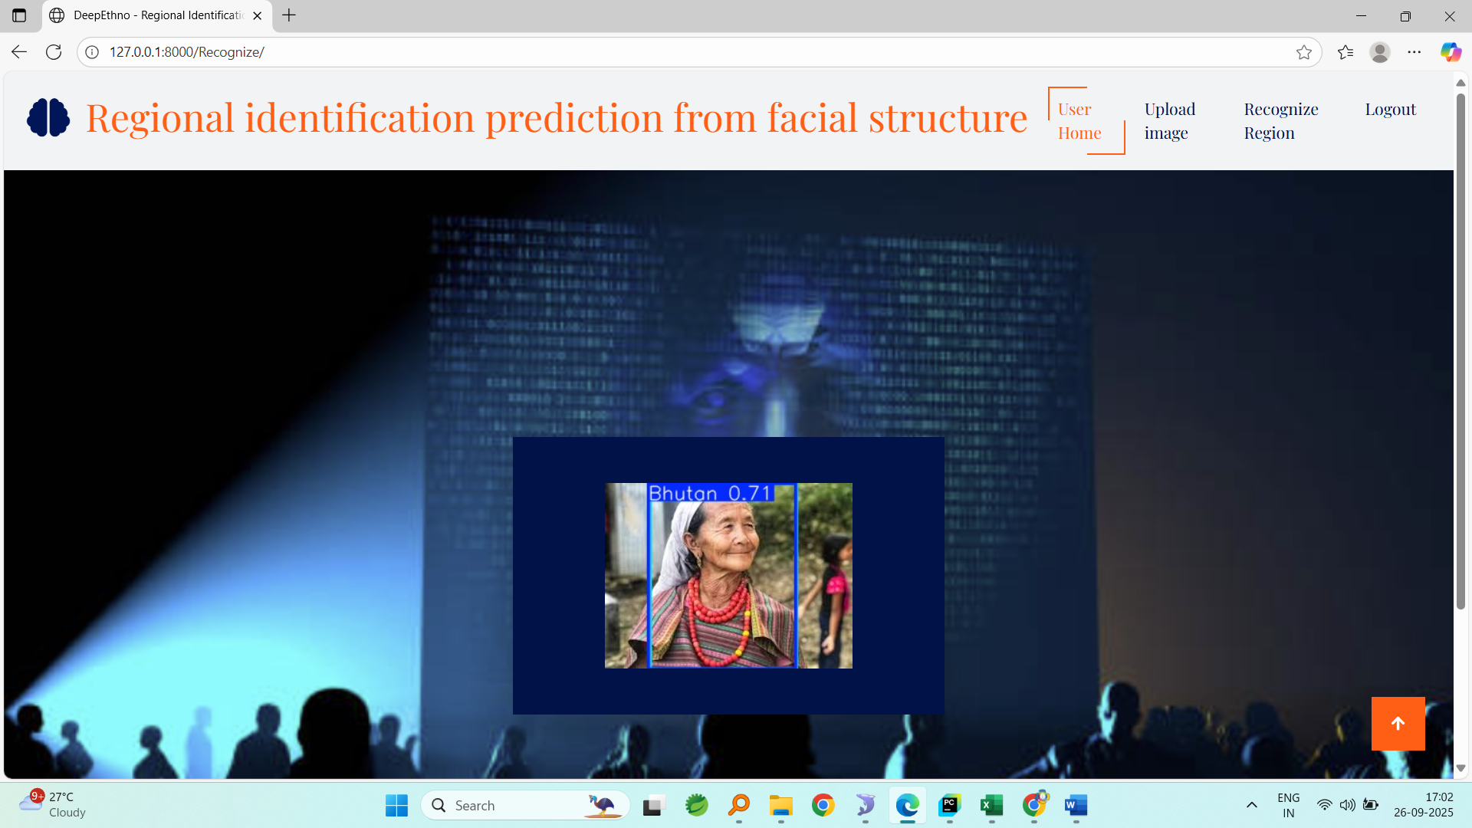
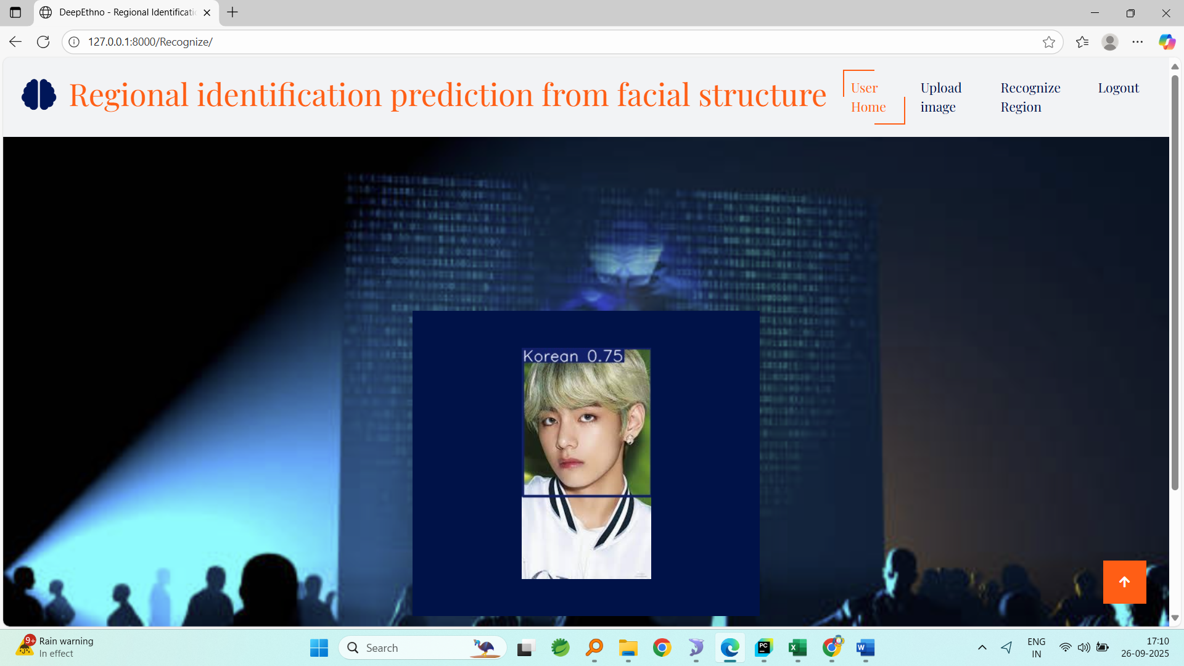

CONCLUSION

The DeepEthno system demonstrates the potential of applying modern deep-learning architectures, specifically YOLOv8, to the task of regional identification based on facial structures. By leveraging datasets from diverse populations such as Bhutan, Brazil, Dubai, India, Korea, Nigeria, and South Africa, the system is able to learn distinctive structural and morphological cues that differentiate individuals across regions. The modular framework integrates dataset management, model training, and user-facing recognition into a cohesive academic prototype, thereby providing both technical robustness and practical usability.
The research highlights not only the technical feasibility but also the importance of fairness, reproducibility, and ethical considerations in demographic recognition systems. Compared to traditional recognition systems, DeepEthno benefits from YOLOv8’s anchor-free detection and classification capabilities, achieving both high accuracy and real-time inference speed. At the same time, the study acknowledges the limitations arising from dataset imbalance, cross-cultural biases, and the potential misuse of demographic recognition technologies.
Ultimately, DeepEthno serves as an academic contribution rather than a deployable commercial product. Its value lies in demonstrating technical innovation while raising awareness about the ethical and fairness-related challenges of demographic prediction systems. The project establishes a foundation for future research in fairness-aware computer vision and reproducible deep-learning workflows, ensuring that academic prototypes are responsibly documented and clearly distinguished from real-world deployments.

FUTURE SCOPE
The future direction of DeepEthno research involves both technical enhancements and ethical safeguards. On the technical side, the system can be expanded with larger and more balanced datasets covering additional countries and ethnicities to reduce bias and improve generalization. Advanced augmentation techniques, such as generative adversarial networks (GANs) for synthetic face generation, can help fill underrepresented groups and improve fairness in training. Incorporating explainable AI (XAI) methods will enable greater interpretability by showing which facial features drive classification decisions, helping to validate results and expose potential biases.
In terms of deployment, the model can be optimized for cross-platform compatibility using lightweight formats such as TensorRT, CoreML, or ONNX, making it accessible for academic demonstrations across mobile and edge devices. Another promising direction is to explore multimodal systems by combining facial cues with contextual information (such as speech, clothing, or cultural artifacts) to enhance classification robustness. Privacy-preserving machine learning approaches like federated learning and encrypted inference should also be investigated to ensure that sensitive biometric data is never exposed.
From an ethical perspective, the project must include comprehensive fairness evaluations, per-region performance reporting, and strong disclaimers about academic-only use. Collaborative efforts with sociologists, ethicists, and policymakers will also enrich the system by integrating cultural awareness and mitigating potential misuse. Long term, the DeepEthno framework can evolve into a broader research platform for fairness-aware biometric analysis, contributing to global discussions about responsible AI in demographic recognition.

REFERENCES

- Ultralytics, “YOLOv8 — Models & Usage,” Ultralytics Docs, Jan. 2023.
- D. Reis, “Real-Time Flying Object Detection with YOLOv8,” arXiv preprint, May 2023.
- N. Ladi, “Running Ultralytics object detection and segmentation models in a few lines of code,” Ultralytics Blog, Jun. 2024.
- Z. Zhang et al., “Validating Privacy-Preserving Face Recognition under a Minimum Assumption,” Proc. CVPR, 2024.
- A. Sumsion, “Surveying Racial Bias in Facial Recognition: Balancing Accuracy and Fairness,” Electronics, 2024.
- Q. Zhang et al., “Understanding of facial features in face perception: insights for computational models,” Frontiers in Computational Neuroscience, 2024.
- “What is YOLOv8: An In-Depth Exploration,” arXiv preprint, Aug. 2024.
- Roboflow, “What is YOLOv8? A Complete Guide,” Roboflow Blog, Oct. 2024.
- S. Mupparaju et al., “A Review on YOLOv8 and Its Advancements,” ResearchGate, 2024.
- “Review of Demographic Fairness in Face Recognition,” arXiv preprint, 2025.

